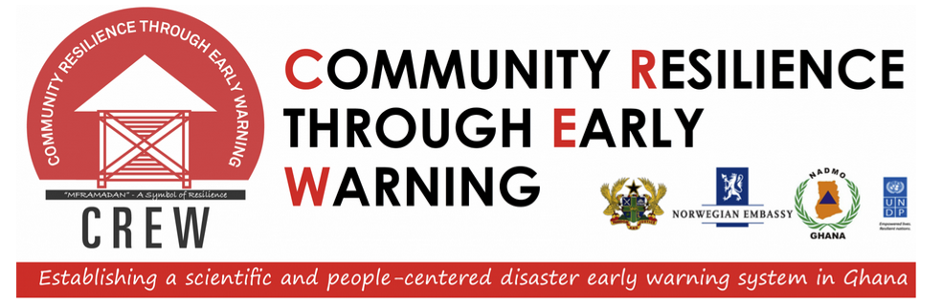
REPORT ON CREW REGIONAL CONSULTATIVE WORKSHOPS

12TH NOVEMBER – 6TH DECEMBER, 2013

BY
CREW PROJECT MANAGEMENT UNIT
DEC, 2013

Content
List of Tables v
List of Figures vi
1.0 Background 1
1.1 Workshop Programme 1
2.0 Volta Regional Consultative Workshop Report 4
2.1 Workshop Opening 4
2.2 Welcome Address 4
2.3 CREW Project Overview, Baseline Data, and Workshop Objectives 5
2.4 Session 1: Envisioning an Effective Regional Early Warning System 5
2.5 Session 2: Recent Efforts Related to Early Warning System in Ghana and the Region 6
2.6 Session 3: Pilot Sites Selection 7
3.0 Western Regional Consultative Workshop Report 8
3.1 Workshop Opening 8
3.2 Welcome Address 8
3.3 CREW Project Overview, Baseline Data, and Workshop Objectives 9
3.4 Session 1: Envisioning an Effective Regional Early Warning System 9
3.5 Session 2: Recent Efforts Related to Early Warning System in Ghana and the Region 9
3.6 Session 3: Pilot Sites Selection 10
4.0 Central Regional Consultative Workshop Report 12
4.1 Workshop Opening 12
4.2 Welcome Address 12
4.3 CREW Project Overview, Baseline Data, and Workshop Objectives 13
4.4 Session 1: Envisioning an Effective Regional Early Warning System 13
4.5 Session 2: Recent Efforts Related to Early Warning System in Ghana and the Region 13
4.6 Session 3: Pilot Sites Selection 14
5.0 Eastern Regional Consultative Workshop Report 15
5.1 Workshop Opening 15
5.2 Welcome Address 15
5.3 CREW Project Overview, Baseline Data, and Workshop Objectives 15
5.4 Session 1: Envisioning an Effective Regional Early Warning System 16
5.5 Session 2: Recent Efforts Related to Early Warning System in Ghana and the Region 16
5.6 Session 3: Pilot Sites Selection 17
6.0 Greater Accra Regional Consultative Workshop Report 18
6.1 Workshop Opening 18
6.2 Welcome Address 18
6.3 CREW Project Overview, Baseline Data, and Workshop Objectives 19
6.4 Session 1: Envisioning an Effective Regional Early Warning System 19
6.5 Session 2: Recent Efforts Related to Early Warning System in Ghana and the Region 20
6.6 Session 3: Pilot Sites Selection 20
7.0 Ashanti Regional Consultative Workshop Report 22
7.1 Workshop Opening 22
7.2 Welcome Address 22
7.3 CREW Project Overview, Baseline Data, and Workshop Objectives 22
7.4 Session 1: Envisioning an Effective Regional Early Warning System 23
7.5 Session 2: Recent Efforts Related to Early Warning System in Ghana and the Region 23
7.6 Session 3: Pilot Sites Selection 24
8.0 Brong Ahafo Regional Consultative Workshop Report 25
8.1 Workshop Opening 25
8.2 Welcome Address 25
8.3 CREW Project Overview, Baseline Data, and Workshop Objectives 26
8.4 Session 1: Envisioning an Effective Regional Early Warning System 26
8.5 Session 2: Recent Efforts Related to Early Warning System in Ghana and the Region 27
8.6 Session 3: Pilot Sites Selection 27
9.0 Upper West Regional Consultative Workshop Report 29
9.1 Workshop Opening 29
9.2 Welcome Address 29
9.3 CREW Project Overview, Baseline Data, and Workshop Objectives 30
9.4 Session 1: Envisioning an Effective Regional Early Warning System 30
9.5 Session 2: Recent Efforts Related to Early Warning System in Ghana and the Region 31
9.6 Session 3: Pilot Sites Selection 31
10.0 Northern Regional Consultative Workshop Report 33
10.1 Workshop Opening 33
10.2 Welcome Address 33
10.3 CREW Project Overview, Baseline Data, and Workshop Objectives 34
10.4 Session 1: Envisioning an Effective Regional Early Warning System 34
10.5 Session 2: Recent Efforts Related to Early Warning System in Ghana and the Region 35
10.6 Session 3: Pilot Sites Selection 36
11.0 Upper East Regional Consultative Workshop Report 37
11.1 Workshop Opening 37
11.2 Welcome Address 37
11.3 CREW Project Overview, Baseline Data, and Workshop Objectives 37
11.4 Session 1: Envisioning an Effective Regional Early Warning System 38
11.5 Session 2: Recent Efforts Related to Early Warning System in Ghana and the Region 38
11.6 Session 3: Pilot Sites Selection 39
Appendix I: CREW Inception Workshop Programme 40
Appendix II: Word Game 41
Appendix III: Site Selection Matrix APPENDIX IV: POST WORKSHOP PARTICIPANT SURVEY 42
APPENDIX IV: POST WORKSHOP PARTICIPANT SURVEY 43
Appendix V: TERMS OF REFERENCE 44
Appendix VI: Participant Lists for CREW Regional Consultative Workshops 48

List of Tables
Table 1: CREW Regional Consultative Workshop Schedule 2
Table 2: Synonyms of key words given by participants in Ho 6
Table 3: Top 5 Flood and Drought Prone Districts in the Volta Region 7
Table 4: Synonyms of key words given by participants in Takoradi 9
Table 5: Top 5 Flood Prone Districts in the Western Region 10
Table 6: Synonyms of key words given by participants in Cape Coast 13
Table 7: Top 5 Flood and Drought Prone Districts in the Central Region 14
Table 8: Synonyms of key words given by participants in Cape Coast 16
Table 9: Top 5 Flood and Drought Prone Districts in the Eastern Region 17
Table 10: Synonyms of key words given by participants in Accra 19
Table 11: Top 5 Flood and Drought Prone Districts in the Greater Accra Region 21
Table 12: Synonyms of key words given by participants in Kumasi 23
Table 13: Top 5 Flood and Drought Prone Districts in the Ashanti Region 24
Table 14: Synonyms of key words given by participants in Sunyani 26
Table 15: Top 5 Flood and Drought Prone Districts in the Brong Ahafo Region 28
Table 16: Synonyms of key words given by participants in Wa 30
Table 17: Top 5 Flood and Drought Prone Districts in the Upper West Region 32
Table 18: Synonyms of key words given by participants in Tamale 35
Table 19: Top 5 Flood and Drought Prone Districts in the Northern Region 36
Table 20: Synonyms of key words given by participants in Bolgatanga 38
Table 21: Top 5 Flood and Drought Prone Districts in the Upper East Region 39

List of Figures
Figure 1: Ho Participants 4
Figure 2: Takoradi Participants 8
Figure 3: Cape Coast Participants 12
Figure 4: Koforidua Participants 15
Figure 5: Accra Participants 18
Figure 6: Kumasi Participants 22
Figure 7: Sunyani Participants 25
Figure 8: Wa Participants 29
Figure 9: Tamale Participants 33
Figure 10: Bolgatanga Participants 37

Background
Disaster Risk Reduction (DRR) is an urgent and significant development issue in Ghana. Recognizing the importance of strengthening DRR capacities in achieving sustainable development and poverty reduction in Ghana, the National Disaster Management Organization (NADMO) with funding from the Government of Norway, and in partnership with the United Nations Development Programme (UNDP), has initiated the “Community Resilience through Early Warning (CREW) Project.” Over the three-year (2013 to 2015) implementation period, the CREW Project aims to build capacities within the country to reduce disaster risk by putting in place an integrated early warning system that is both scientific and people-centred.

The project is designed in a way that aligns it with the Hyogo Framework of Action and the Ghana Plan of Action for DRR and CCA, and leads to tangible results at both national and community levels. Through the implementation of hazard mapping, early warning, and vulnerability assessment and reduction, the CREW Project aims to achieve 1) reduction of economic and human losses and damages from priority disasters, and 2) establishment of effective early warning and communication for priority hazards to reduce disaster risks in 10 pilot sites by 2015.

Following the official launch of the CREW project at the national level in Accra there was the need to hold Regional consultative workshops to formally inform and launch the project for key stakeholders in the ten (10) beneficiary Regions of the country, build partnership among key regional stakeholders and choose tentative pilot sites for DRR and EWS activities. The one-day workshop involved key regional actors related to the management of climate induced disasters as well as those germane to the establishment of Early Warning System (EWS) This report details the activities and outputs from the regional consultative workshops held in each of the 10 regional capitals of Ghana.

Workshop Programme
The CREW regional consultative workshops were held from 13th November 2013 to 4th October 2013 in all the 10 regional capitals of Ghana (see Table 1 for the workshop schedule).

Table 1: CREW Regional Consultative Workshop Schedule
Day | Date | Task
Wed | 13-11-13 | Volta Region Workshop
Fri | 15-11-13 | Western Region Workshop
Mon | 18-11-13 | Central Region Workshop
Wed | 20-11-13 | Eastern Region Workshop
Fri | 22-11-13 | Greater Accra Workshop
Mon | 25-11-13 | Ashanti Regional Workshop
Wed | 27-11-13 | Brong-Ahafo Regional Workshop
Fri | 29-11-13 | Upper West Regional Workshop
Mon | 02-12-13 | Northern Regional Workshop
Wed | 04-12-13 | Upper East Regional Workshop

The programme for all ten regional consultative workshops followed the same schedule (see annex I for workshop programme). This involved a formal opening and introduction of participants followed by a welcome address by the regional NADMO host. The keynote address is subsequently delivered by either the Regional Minister or an RCC representative. The next activity is a presentation by the CREW project manager who provides an overview of the CREW Project, baseline data on disasters in Ghana as well as the objectives of the workshop.

The first session of the workshops focused on two group activities. The first activity is a word game that focuses on stimulating creative and “out-of-the-box” thinking in envisioning an effective early warning system. Participants are split into groups and asked to come out with synonyms to words such as community, disaster, resilience and early warning and to ultimately provide their own understanding and definition of what CREW stands for. The second activity of the session is also a group exercise on designing a flood/drought resilient community and the presentation of the corresponding output by group leaders in the plenary session.

The second session of the workshops comprised two presentations that dwelt on recent efforts related to flood and drought risk mapping through AAP and indigenous knowledge on flood and drought early warning respectively. The CREW Technical Advisor, Mr. Philip Mantey, presented the approach, methodology and results of the flood and drought risk mapping assignment undertaken in 5 pilot districts under the African Adaptation Project. The beneficiary districts were Aowin Suaman in the Western Region, Fanteakwa in the Eastern Region, Keta in the Volta Region, West Mamprusi in the Northern Region and Sissala East in the Upper West Region. The second presentation on indigenous knowledge on flood and drought early warning was presented by Dr. Kingsford Asamoah, the CREW Project Manager. This focused on district specific indigenous early warning knowledge on droughts and floods also from the five AAP pilot districts already mention.

The third and final session of the workshops involved a group activity on the selection of pilot sites for flood and drought risk mapping and early warning system development using a scoring matrix developed by the CREW Research Technical Working Group. All the districts in each of regions are scored on the different criteria relating to flood and drought hazards, vulnerability and capacity. The top five districts per region in terms of flood and drought disasters are then shortlisted as input into the final site selection. The workshops ended with a survey of participants and a closing prayer.

Volta Regional Consultative Workshop Report

Workshop Opening
The Volta Regional consultative workshop was held on the 13th of November 2013 at the SkyPlus Hotel in Ho. The workshop was opened with a prayer from one of the participants. This was followed by the introduction of participants of the workshop (Fig. 1). The list of all the participants of the Volta Regional Consultative Workshop is provided in Annex V.
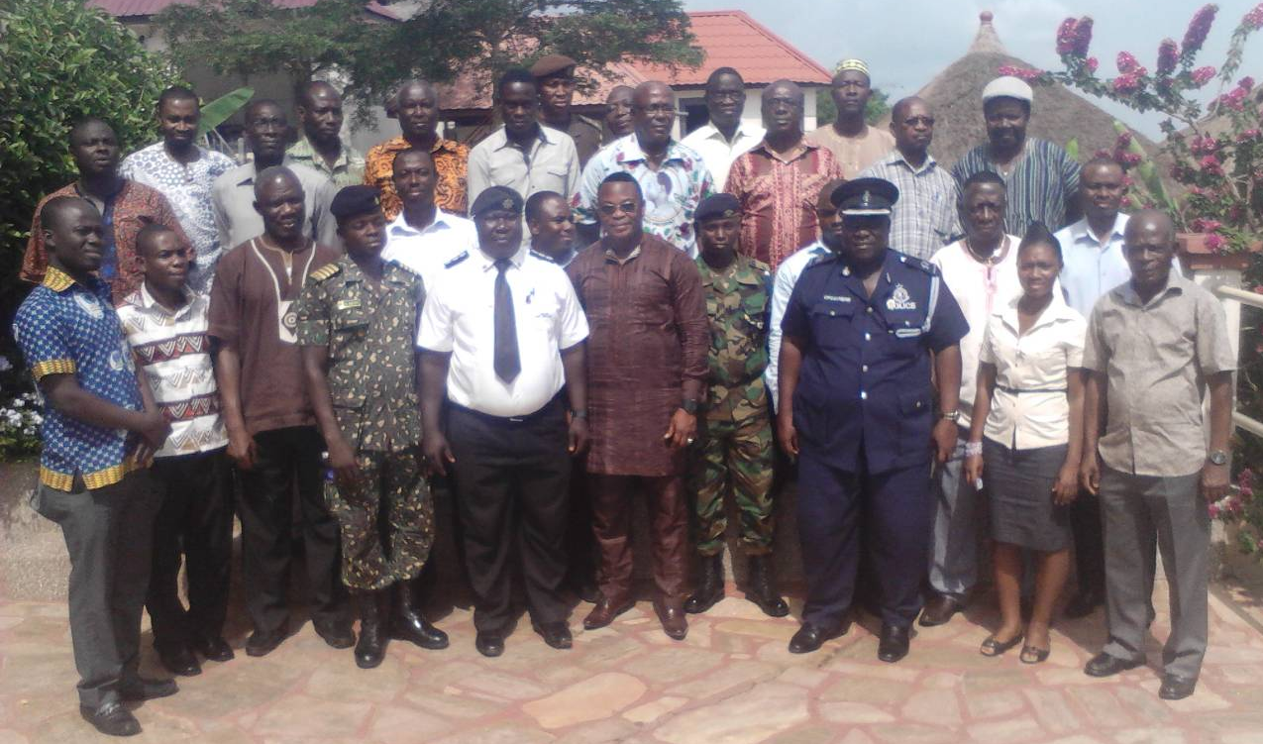

Figure 1: Ho Participants

Welcome Address
The welcome address was delivered by Mr. Mintah who represented the Volta Regional Minister. In his address, Mr. Mintah lamented the difficult start to the year in terms of disaster occurrences in the country. He indicated that he was glad that NADMO had been able to prevail in the face of the challenges. He said that the workshop affords a good opportunity for knowledge sharing in disasters in the country. He welcomed participants to the Volta Region which he said represented a microcosm of the larger Ghanaian territory in as evidence in its ethnic and ecological characteristics.
The chairperson for the occasion, Mr. Nat King Tackie was also the platform chairman for disasters in the Volta Region. In his address, he stressed that dealing with disasters is not a preserve for the government alone but must also involve the larger society. He observed that Disaster risk reduction was an urgent imperative in Ghana and believed that the CREW project was very timely. He called on participants to bring their minds to bear on the issues to be discussed during the various sessions of the workshop.

CREW Project Overview, Baseline Data, and Workshop Objectives
Dr. Kingsford Asamoah, the CREW project manager presented an overview of the CREW project, the objectives of the regional consultative workshop as well as baseline data on disasters in the country that was culled from the Daily Graphic for the period spanning 1987 to present.

Session 1: Envisioning an Effective Regional Early Warning System
The first session of the workshop focused on two group activities. The first activity was a word game that focused on stimulating creative and “out-of-the-box” thinking in envisioning an effective early warning system. Participants were split into groups and asked to come out with synonyms to words such as community, disaster, resilience and early warning and to ultimately provide their own understanding and definition of what CREW stands for. Table 1 presents the collated outputs from the various groups from this exercise. The second activity of session 1 was also a group exercise on designing a flood/drought resilient community and the presentation of the corresponding output by group leaders in the plenary session.

Table 2: Synonyms of key words given by participants in Ho
Community | Village, Town, Cottage, Settlement, Suburb, Neighbourhood, Zone, Enclave, Habitat, Hamlet.
Disaster | Catastrophy, Calamity, Accident, Mishap, Plague, Distress, Conflict, Destruction.
Resilience | Endurance, Cope, Stability, Preventive, Withstand, Protective, Recover, Healthy, Regain, Fence, Overcome, Robust.
Early Warning | Alert, Sensitize, Alarm, Awareness, Forecast, Foreknowledge, Information, Prediction, Readiness, Preparedness.

Session 2: Recent Efforts Related to Early Warning System in Ghana and the Region
The second session of the workshops comprised two presentations that dwelt on recent efforts related to flood and drought risk mapping through AAP and indigenous knowledge on flood and drought early warning respectively. Mr. Philip Mantey, the CREW Technical Advisor delivered a presentation on the flood and drought risk mapping assignment undertaken in 5 pilot districts under the African Adaptation Project. The beneficiary districts were Aowin Suaman in the Western Region, Fanteakwa in the Eastern Region, Keta in the Volta Region, West Mamprusi in the Northern Region and Sissala East in the Upper West Region.The presentation focused on a GIS based approach to modelling flood and drought risk in the pilot districts using meteorological and topographical data in a multicriteria framework. The output maps were symbolised using a traffic light code of red-yellow-green denoting high risk-medium risk-low risk areas to drought or flood. The presentation showed the importance of knowing the spatial risk levels for different areas within the districts to enable the proper citing of safe havens and evacuation routes in case of flood disasters in particular.

The second presentation focused on indigenous knowledge on flood and drought early warning was presented by Dr. Kingsford Asamoah, the CREW Project Manager. This focused on district specific indigenous early warning knowledge on droughts and floods also from the five AAP pilot districts already mention. The indigenous knowledge on flood and drought early warning are based on the observation of natural occurrences such as the movement of animals, weather signs that have over time been associated with the flood and drought events as experienced by the indigenous populations in these districts.

Session 3: Pilot Sites Selection
The pilot site selection exercise by participants was based on a scoring matrix developed by the CREW Research Technical Working Group (See Annex III). The five top districts for flood and drought disasters in the region are presented in Tables 3.

Table 3: Top 5 Flood and Drought Prone Districts in the Volta Region
Flood | Drought
Akatsi South | Adaklu
Keta | Afadjato
Adaklu | Agortime Ziope
Afadjato | Akatsi North
Nkwanta South | Akatsi South

Western Regional Consultative Workshop Report

Workshop Opening
The Western Regional consultative workshop was held on the 15th of November 2012 in Takoradi at the Hillcrest Hotel. The workshop was opened with a prayer by Reverend Ernest Kofi of the regional platform. Introduction of workshop participants (Fig. 2) followed the opening prayer. The list of the participants of the Western Regional Consultative workshop is provided in Annex V.

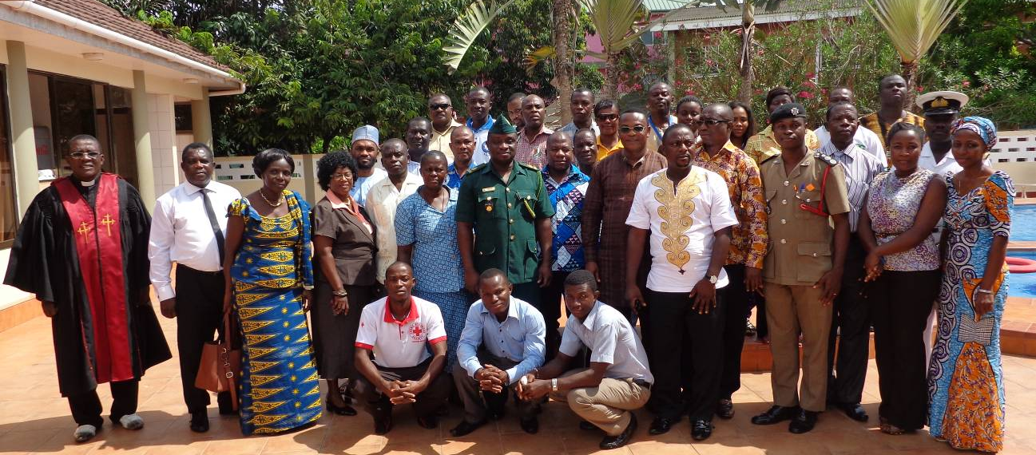

Figure 2: Takoradi Participants

Welcome Address
A short welcome address was given by the Regional NADMO Coordinator, Mr. Japheth Baidoo. He stressed the importance that disasters all over the world have attracted, thus necessitating the development of the Hyogo Framework for Action. He indicated that Ghana had already achieved Priority 1 of the framework which is to ensure that disaster risk reduction is made a national and a local priority with a strong institutional basis for implementation. He encouraged participants to give the workshop their necessary attention during the deliberations.

CREW Project Overview, Baseline Data, and Workshop Objectives
Dr. Kingsford Asamoah, the CREW project manager presented an overview of the CREW project, the objectives of the regional consultative workshop as well as baseline data on disasters in the country that was culled from the Daily Graphic for the period spanning 1987 to present.

Session 1: Envisioning an Effective Regional Early Warning System
The first session of the workshop focused on two group activities. The first activity was a word game that focused on stimulating creative and “out-of-the-box” thinking in envisioning an effective early warning system. Participants were split into groups and asked to come out with synonyms to words such as community, disaster, resilience and early warning and to ultimately provide their own understanding and definition of what CREW stands for. Table 4 presents the collated outputs from the various groups from this exercise. The second activity of session 1 was also a group exercise on designing a flood/drought resilient community and the presentation of the corresponding output by group leaders in the plenary session.

Table 4: Synonyms of key words given by participants in Takoradi
Community | Area, Settlement, Suburb, Vicinity, Society, Town, Village, Location, Place, Habitat
Disaster | Danger, Havoc, Calamity, Misfortune, Calamity, Catastrophe, Destruction, Devastation, Mayhem, Mishap
Resilience | Withstand, Resistance, Endurance, Resistance, Perseverance, Durability, Tough, Strength, Recovery, Coping
Early Warning | Information, Prediction, Alert, Forecast, Signal, Foretell, Prompting, Foresee, Communication, Caution, Alarm, Signs

Session 2: Recent Efforts Related to Early Warning System in Ghana and the Region
The second session of the workshops comprised two presentations that dwelt on recent efforts related to flood and drought risk mapping through AAP and indigenous knowledge on flood and drought early warning respectively. Mr. Philip Mantey, the CREW Technical Advisor delivered a presentation on the flood and drought risk mapping assignment undertaken in 5 pilot districts under the African Adaptation Project. The beneficiary districts were Aowin Suaman in the Western Region, Fanteakwa in the Eastern Region, Keta in the Volta Region, West Mamprusi in the Northern Region and Sissala East in the Upper West Region.The presentation focused on a GIS based approach to modelling flood and drought risk in the pilot districts using meteorological and topographical data in a multicriteria framework. The output maps were symbolised using a traffic light code of red-yellow-green denoting high risk-medium risk-low risk areas to drought or flood. The presentation showed the importance of knowing the spatial risk levels for different areas within the districts to enable the proper citing of safe havens and evacuation routes in case of flood disasters in particular.

The second presentation focused on indigenous knowledge on flood and drought early warning was presented by Dr. Kingsford Asamoah, the CREW Project Manager. This focused on district specific indigenous early warning knowledge on droughts and floods also from the five AAP pilot districts already mention. The indigenous knowledge on flood and drought early warning are based on the observation of natural occurrences such as the movement of animals, weather signs that have over time been associated with the flood and drought events as experienced by the indigenous populations in these districts.

Session 3: Pilot Sites Selection
The pilot site selection exercise by participants was based on a scoring matrix developed by the CREW Research Technical Working Group (See Annex III). The five top districts for flood and drought disasters in the region as selected by participants are presented in Table 5.

Table 5: Top 5 Flood Prone Districts in the Western Region
Flood | Drought
Sekondi Takoradi | Elembele
Tarkwa Nsuaem | Jomoro
Prestea Huni Valley | Bia West
Shama | Bia East
Bibiani | Suaman

Central Regional Consultative Workshop Report

Workshop Opening
The Central Regional consultative workshop was held on the 18th November 2012 in Cape Coast at the Sanaa Lodge. The workshop was opened with a prayer by a participant. This was followed by the introduction of participants (Fig 3). The list of the participants of the Central Regional Consultative Workshop is provided in Annex V.

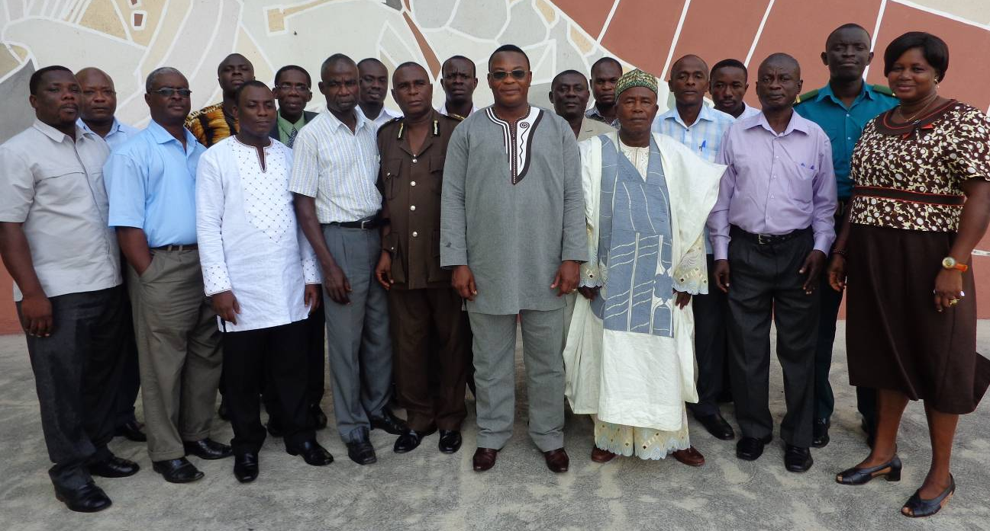

Figure 3: Cape Coast Participants

Welcome Address

CREW Project Overview, Baseline Data, and Workshop Objectives
Dr. Kingsford Asamoah, the CREW project manager presented an overview of the CREW project, the objectives of the regional consultative workshop as well as baseline data on disasters in the country that was culled from the Daily Graphic for the period spanning 1987 to present.

Session 1: Envisioning an Effective Regional Early Warning System
The first session of the workshop focused on two group activities. The first activity was a word game that focused on stimulating creative and “out-of-the-box” thinking in envisioning an effective early warning system. Participants were split into groups and asked to come out with synonyms to words such as community, disaster, resilience and early warning and to ultimately provide their own understanding and definition of what CREW stands for. Table 6 presents the collated outputs from the various groups from this exercise. The second activity of session 1 was also a group exercise on designing a flood/drought resilient community and the presentation of the corresponding output by group leaders in the plenary session.

Table 6: Synonyms of key words given by participants in Cape Coast
Community | Township, Settlement, Village, Dwelling, Estate
Disaster | Threats, Events, Hazard, Calamity, Catastrophe, Accident, Crisis
Resilience | Capacity, Withstand, Bounce back, Endurance, Prevention
Early Warning | Alert, Alarm, Sign, Symptom, Fore Knowledge, Indication, Detection, Caution.

Session 2: Recent Efforts Related to Early Warning System in Ghana and the Region
The second session of the workshops comprised two presentations that dwelt on recent efforts related to flood and drought risk mapping through AAP and indigenous knowledge on flood and drought early warning respectively. Mr. Philip Mantey, the CREW Technical Advisor delivered a presentation on the flood and drought risk mapping assignment undertaken in 5 pilot districts under the African Adaptation Project. The beneficiary districts were Aowin Suaman in the Western Region, Fanteakwa in the Eastern Region, Keta in the Volta Region, West Mamprusi in the Northern Region and Sissala East in the Upper West Region.The presentation focused on a GIS based approach to modelling flood and drought risk in the pilot districts using meteorological and topographical data in a multicriteria framework. The output maps were symbolised using a traffic light code of red-yellow-green denoting high risk-medium risk-low risk areas to drought or flood. The presentation showed the importance of knowing the spatial risk levels for different areas within the districts to enable the proper citing of safe havens and evacuation routes in case of flood disasters in particular.

The second presentation focused on indigenous knowledge on flood and drought early warning was presented by Dr. Kingsford Asamoah, the CREW Project Manager. This focused on district specific indigenous early warning knowledge on droughts and floods also from the five AAP pilot districts already mention. The indigenous knowledge on flood and drought early warning are based on the observation of natural occurrences such as the movement of animals, weather signs that have over time been associated with the flood and drought events as experienced by the indigenous populations in these districts.

Session 3: Pilot Sites Selection
The pilot site selection exercise by participants was based on a scoring matrix developed by the CREW Research Technical Working Group (See Annex III). The five top districts for flood and drought disasters in the region as selected by participants are presented in Table 7.

Table 7: Top 5 Flood and Drought Prone Districts in the Central Region
Flood | Drought
Komenda Edina Ebirem | Ekumfi
Cape Coast | Gomoa East
Agona West | Cape Coast
Efutu | Agona West
Gomoa West | Awutu Senya

Eastern Regional Consultative Workshop Report

Workshop Opening
The Eastern Regional consultative workshop was held on the 20th November 2012 in Koforidua at the Mac Dic Royal Plaza Hotel. The workshop was opened with a prayer by a participant. This was followed by the introduction of participants (Fig 4). The list of the participants of the Eastern Regional Consultative Workshop is provided in Annex V.

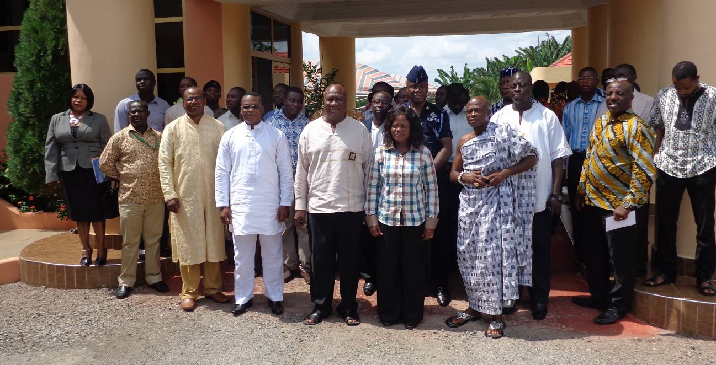

Figure 4: Koforidua Participants

Welcome Address

CREW Project Overview, Baseline Data, and Workshop Objectives
Dr. Kingsford Asamoah, the CREW project manager presented an overview of the CREW project, the objectives of the regional consultative workshop as well as baseline data on disasters in the country that was culled from the Daily Graphic for the period spanning 1987 to present.

Session 1: Envisioning an Effective Regional Early Warning System
The first session of the workshop focused on two group activities. The first activity was a word game that focused on stimulating creative and “out-of-the-box” thinking in envisioning an effective early warning system. Participants were split into groups and asked to come out with synonyms to words such as community, disaster, resilience and early warning and to ultimately provide their own understanding and definition of what CREW stands for. Table 8 presents the collated outputs from the various groups from this exercise. The second activity of session 1 was also a group exercise on designing a flood/drought resilient community and the presentation of the corresponding output by group leaders in the plenary session.

Table 8: Synonyms of key words given by participants in Cape Coast
Community | Township, Settlement, Village, Dwelling, Estate, Vicinity, Catchment,
Disaster | Threats, Events, Hazard, Calamity, Catastrophe, Accident, Crisis, Destruction, incident
Resilience | Capacity, Withstand, Bounce back, Endurance, Prevention, Fortified, Strengthened
Early Warning | Alert, Alarm, Sign, Symptom, Fore Knowledge, Indication, Detection, Caution.

Session 2: Recent Efforts Related to Early Warning System in Ghana and the Region
The second session of the workshops comprised two presentations that dwelt on recent efforts related to flood and drought risk mapping through AAP and indigenous knowledge on flood and drought early warning respectively. Mr. Philip Mantey, the CREW Technical Advisor delivered a presentation on the flood and drought risk mapping assignment undertaken in 5 pilot districts under the African Adaptation Project. The beneficiary districts were Aowin Suaman in the Western Region, Fanteakwa in the Eastern Region, Keta in the Volta Region, West Mamprusi in the Northern Region and Sissala East in the Upper West Region.The presentation focused on a GIS based approach to modelling flood and drought risk in the pilot districts using meteorological and topographical data in a multicriteria framework. The output maps were symbolised using a traffic light code of red-yellow-green denoting high risk-medium risk-low risk areas to drought or flood. The presentation showed the importance of knowing the spatial risk levels for different areas within the districts to enable the proper citing of safe havens and evacuation routes in case of flood disasters in particular.

The second presentation focused on indigenous knowledge on flood and drought early warning was presented by Dr. Kingsford Asamoah, the CREW Project Manager. This focused on district specific indigenous early warning knowledge on droughts and floods also from the five AAP pilot districts already mention. The indigenous knowledge on flood and drought early warning are based on the observation of natural occurrences such as the movement of animals, weather signs that have over time been associated with the flood and drought events as experienced by the indigenous populations in these districts.

Session 3: Pilot Sites Selection
The pilot site selection exercise by participants was based on a scoring matrix developed by the CREW Research Technical Working Group (See Annex III). The five top districts for flood and drought disasters in the region as selected by participants are presented in Table 9.

Table 9: Top 5 Flood and Drought Prone Districts in the Eastern Region
Flood | Drought
New Juaben | New Juaben
Suhum Kraboa Coaltar | Lower Manya Krobo
Yilo Krobo | Afram Plains North
West Akim | Kwahu
Fanteakwa | Birim Central

Greater Accra Regional Consultative Workshop Report

Workshop Opening
The Greater Accra Regional consultative workshop was held on the 22nd November 2012 in Accra at the M-Plaza Hotel. The workshop was opened with a prayer by a participant. This was followed by the introduction of participants (Fig 5). The list of the participants of the Central Regional Consultative Workshop is provided in Annex V.

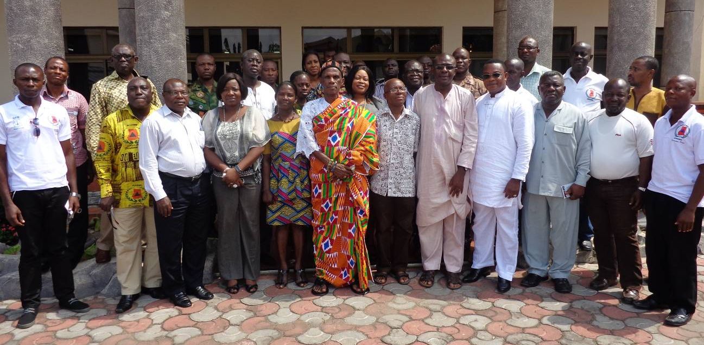

Figure 5: Accra Participants

Welcome Address
Mr. Ebenezer Dosoo, the Deputy National Coordinator of NADMO (Technical) delivered the keynote address on behalf of Mr. Portuphy. He spoke of the help from the Norwegian Embassy through the instrumentation of the late President JEA Mills. He delved into the import of the CREW project particularly on the fusion of the scientific and indigenous knowledge.

CREW Project Overview, Baseline Data, and Workshop Objectives
Dr. Kingsford Asamoah, the CREW project manager presented an overview of the CREW project, the objectives of the regional consultative workshop as well as baseline data on disasters in the country that was culled from the Daily Graphic for the period spanning 1987 to present.

Session 1: Envisioning an Effective Regional Early Warning System
The first session of the workshop focused on two group activities. The first activity was a word game that focused on stimulating creative and “out-of-the-box” thinking in envisioning an effective early warning system. Participants were split into groups and asked to come out with synonyms to words such as community, disaster, resilience and early warning and to ultimately provide their own understanding and definition of what CREW stands for. Table 10 presents the collated outputs from the various groups from this exercise. The second activity of session 1 was also a group exercise on designing a flood/drought resilient community and the presentation of the corresponding output by group leaders in the plenary session.

Table 10: Synonyms of key words given by participants in Accra
Community | Surroundings, Town, Hamlet, Chalet, Habitat, Vicinity, Location Neighbourhood, Cottage, Settlement, Village, Dwelling, Estate , Township, Environment
Disaster | Calamity, Destruction, Epidemic, Pandemic, Devastation, Accident, Fire Outbreak, Flood, Earthquake, Emergency, Catastrophe, Hazard, Tragedy, Loss, Damages, Mishap, Misfortune, Distress
Resilience | Resistance, Defence, Protection, Capacity, Withstand, Bounce back, Endurance, Prevention, Reinforcement, Strong, Fortified, Well Prepared, Toughness, Impregnable, Secured.
Early Warning | Education, Information, Caution, Signals, Alarm, Alert, Preparedness, Awareness, Sign, Symptom, Fore Knowledge, Fore warned, Pre Notice, Pre-informed, Caution.

Session 2: Recent Efforts Related to Early Warning System in Ghana and the Region
The second session of the workshops comprised two presentations that dwelt on recent efforts related to flood and drought risk mapping through AAP and indigenous knowledge on flood and drought early warning respectively. Mr. Philip Mantey, the CREW Technical Advisor delivered a presentation on the flood and drought risk mapping assignment undertaken in 5 pilot districts under the African Adaptation Project. The beneficiary districts were Aowin Suaman in the Western Region, Fanteakwa in the Eastern Region, Keta in the Volta Region, West Mamprusi in the Northern Region and Sissala East in the Upper West Region.The presentation focused on a GIS based approach to modelling flood and drought risk in the pilot districts using meteorological and topographical data in a multicriteria framework. The output maps were symbolised using a traffic light code of red-yellow-green denoting high risk-medium risk-low risk areas to drought or flood. The presentation showed the importance of knowing the spatial risk levels for different areas within the districts to enable the proper citing of safe havens and evacuation routes in case of flood disasters in particular.

The second presentation focused on indigenous knowledge on flood and drought early warning was presented by Dr. Kingsford Asamoah, the CREW Project Manager. This focused on district specific indigenous early warning knowledge on droughts and floods also from the five AAP pilot districts already mention. The indigenous knowledge on flood and drought early warning are based on the observation of natural occurrences such as the movement of animals, weather signs that have over time been associated with the flood and drought events as experienced by the indigenous populations in these districts.

Session 3: Pilot Sites Selection
The pilot site selection exercise by participants was based on a scoring matrix developed by the CREW Research Technical Working Group (See Annex III). The five top districts for flood and drought disasters in the region as selected by participants are presented in Table 11.

Table 11: Top 5 Flood and Drought Prone Districts in the Greater Accra Region
Flood | Drought
Adentan | La Madina Nkwantanan
Accra | La Dadekotopon
Ashaiman | Accra
La Dadekotopon | Ga Central
Tema | Ashaiman

Ashanti Regional Consultative Workshop Report

Workshop Opening
The Ashanti Regional consultative workshop was held on the 25th November 2012 in Kumasi at the Golden Tulip Hotel. The workshop was opened with a prayer by a participant. This was followed by the introduction of participants (Fig 6). The list of the participants of the Ashanti Regional Consultative Workshop is provided in Annex V.

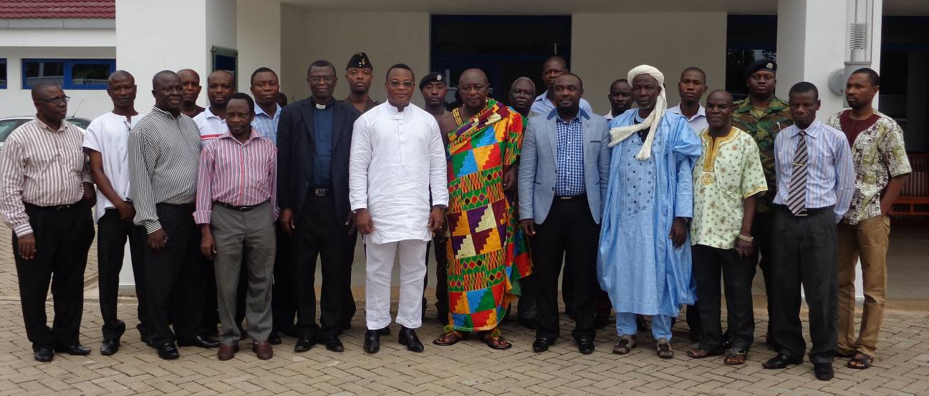

Figure 6: Kumasi Participants

Welcome Address

CREW Project Overview, Baseline Data, and Workshop Objectives
Dr. Kingsford Asamoah, the CREW project manager presented an overview of the CREW project, the objectives of the regional consultative workshop as well as baseline data on disasters in the country that was culled from the Daily Graphic for the period spanning 1987 to present.

Session 1: Envisioning an Effective Regional Early Warning System
The first session of the workshop focused on two group activities. The first activity was a word game that focused on stimulating creative and “out-of-the-box” thinking in envisioning an effective early warning system. Participants were split into groups and asked to come out with synonyms to words such as community, disaster, resilience and early warning and to ultimately provide their own understanding and definition of what CREW stands for. Table 12 presents the collated outputs from the various groups from this exercise. The second activity of session 1 was also a group exercise on designing a flood/drought resilient community and the presentation of the corresponding output by group leaders in the plenary session.

Table 12: Synonyms of key words given by participants in Kumasi
Community | Habitat, Settlement, Village, Society, Locality, Residential Area, Town
Disaster | Accident, Calamity, Catastrophe, Misfortune, Mishap, Tragedy,
Resilience | Resistance, Endurance, Adaptive Capacity, Recovery, Coping, Withstand, Prevention, Buffer,
Early Warning | Alertness, Forecast, Precaution, Prevention, Indicator, Alarm System, Signal,

Session 2: Recent Efforts Related to Early Warning System in Ghana and the Region
The second session of the workshops comprised two presentations that dwelt on recent efforts related to flood and drought risk mapping through AAP and indigenous knowledge on flood and drought early warning respectively. Mr. Philip Mantey, the CREW Technical Advisor delivered a presentation on the flood and drought risk mapping assignment undertaken in 5 pilot districts under the African Adaptation Project. The beneficiary districts were Aowin Suaman in the Western Region, Fanteakwa in the Eastern Region, Keta in the Volta Region, West Mamprusi in the Northern Region and Sissala East in the Upper West Region.The presentation focused on a GIS based approach to modelling flood and drought risk in the pilot districts using meteorological and topographical data in a multicriteria framework. The output maps were symbolised using a traffic light code of red-yellow-green denoting high risk-medium risk-low risk areas to drought or flood. The presentation showed the importance of knowing the spatial risk levels for different areas within the districts to enable the proper citing of safe havens and evacuation routes in case of flood disasters in particular.

The second presentation focused on indigenous knowledge on flood and drought early warning was presented by Dr. Kingsford Asamoah, the CREW Project Manager. This focused on district specific indigenous early warning knowledge on droughts and floods also from the five AAP pilot districts already mention. The indigenous knowledge on flood and drought early warning are based on the observation of natural occurrences such as the movement of animals, weather signs that have over time been associated with the flood and drought events as experienced by the indigenous populations in these districts.

Session 3: Pilot Sites Selection
The pilot site selection exercise by participants was based on a scoring matrix developed by the CREW Research Technical Working Group (See Annex III). The five top districts for flood and drought disasters in the region as selected by participants are presented in Table 13.

Table 13: Top 5 Flood and Drought Prone Districts in the Ashanti Region
Flood | Drought
Obuasi | Asante Akim South
Kumasi | Asante North
Manpong | Offinso North
Bosumtwi | Asante Akim Central
Ejisu Juaben | Ejura Sekyedumase

Brong Ahafo Regional Consultative Workshop Report

Workshop Opening
The Brong Ahafo Regional consultative workshop was held on the 27th November 2012 in Sunyani at the Eusbett Hotel. The workshop was opened with a prayer by a participant. This was followed by the introduction of participants (Fig 7). The list of the participants of the Brong Ahafo Regional Consultative Workshop is provided in Annex V.

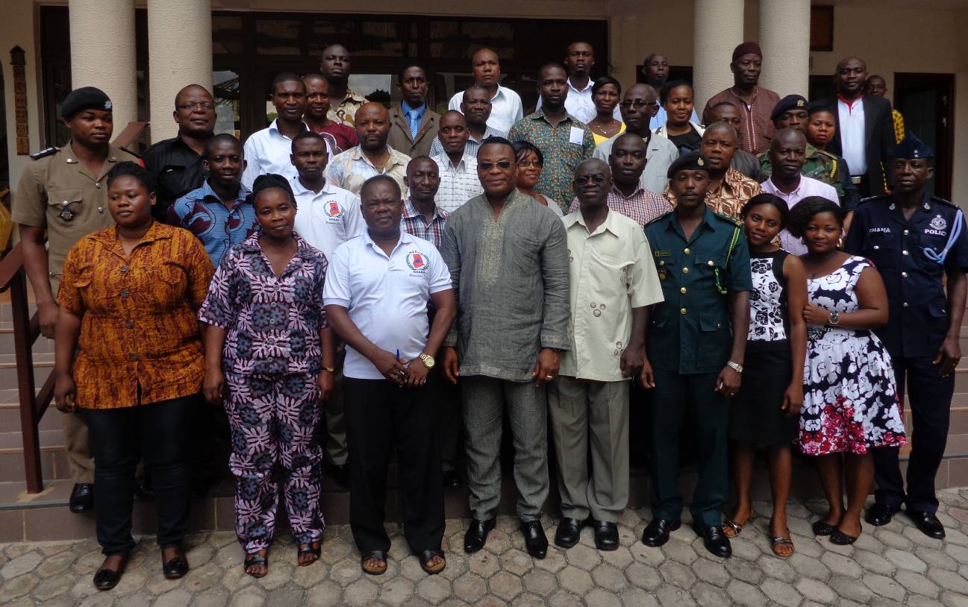
Figure 7: Sunyani Participants

Welcome Address

CREW Project Overview, Baseline Data, and Workshop Objectives
Dr. Kingsford Asamoah, the CREW project manager presented an overview of the CREW project, the objectives of the regional consultative workshop as well as baseline data on disasters in the country that was culled from the Daily Graphic for the period spanning 1987 to present.

Session 1: Envisioning an Effective Regional Early Warning System
The first session of the workshop focused on two group activities. The first activity was a word game that focused on stimulating creative and “out-of-the-box” thinking in envisioning an effective early warning system. Participants were split into groups and asked to come out with synonyms to words such as community, disaster, resilience and early warning and to ultimately provide their own understanding and definition of what CREW stands for. Table 14 presents the collated outputs from the various groups from this exercise. The second activity of session 1 was also a group exercise on designing a flood/drought resilient community and the presentation of the corresponding output by group leaders in the plenary session.

Table 14: Synonyms of key words given by participants in Sunyani
Community | Settlement, Dwelling, Society, Village, Area, Society, Town, Hamlet, Cottage.
Disaster | Destruction, Hazard, Accident, Disruption, Catastrophe, Calamity, Flooding
Resilience | Preparedness, Coping Strategy, Robust, Strength, Resistance, Stability, Resistance, Capacity, Sustainability
Early Warning | Signal, Education, Caution, Indicators, Education, Announcement, Awareness, Alarm, Prior Information

Session 2: Recent Efforts Related to Early Warning System in Ghana and the Region
The second session of the workshops comprised two presentations that dwelt on recent efforts related to flood and drought risk mapping through AAP and indigenous knowledge on flood and drought early warning respectively. Mr. Philip Mantey, the CREW Technical Advisor delivered a presentation on the flood and drought risk mapping assignment undertaken in 5 pilot districts under the African Adaptation Project. The beneficiary districts were Aowin Suaman in the Western Region, Fanteakwa in the Eastern Region, Keta in the Volta Region, West Mamprusi in the Northern Region and Sissala East in the Upper West Region.The presentation focused on a GIS based approach to modelling flood and drought risk in the pilot districts using meteorological and topographical data in a multicriteria framework. The output maps were symbolised using a traffic light code of red-yellow-green denoting high risk-medium risk-low risk areas to drought or flood. The presentation showed the importance of knowing the spatial risk levels for different areas within the districts to enable the proper citing of safe havens and evacuation routes in case of flood disasters in particular.

The second presentation focused on indigenous knowledge on flood and drought early warning was presented by Dr. Kingsford Asamoah, the CREW Project Manager. This focused on district specific indigenous early warning knowledge on droughts and floods also from the five AAP pilot districts already mention. The indigenous knowledge on flood and drought early warning are based on the observation of natural occurrences such as the movement of animals, weather signs that have over time been associated with the flood and drought events as experienced by the indigenous populations in these districts.

Session 3: Pilot Sites Selection
The pilot site selection exercise by participants was based on a scoring matrix developed by the CREW Research Technical Working Group (See Annex III). The five top districts for flood and drought disasters in the region as selected by participants are presented in Table 15.

Table 15: Top 5 Flood and Drought Prone Districts in the Brong Ahafo Region
Flood | Drought
Techiman | Atebubu Amantim
Asutifi South | Sene West
Sunyani | Sene
Asutifi North | Wenchi
Techiman North | Techiman

Upper West Regional Consultative Workshop Report

Workshop Opening
The Upper West Regional consultative workshop was held on the 29th November 2012 in Wa at the Blue Hill Hotel. The workshop was opened with a prayer by a participant. This was followed by the introduction of participants (Fig 8). The list of the participants of the Upper West Regional Consultative Workshop is provided in Annex V.

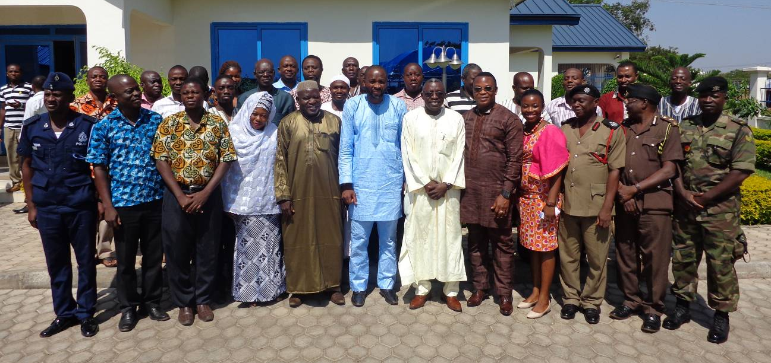
Figure 8: Wa Participants

Welcome Address
The regional NADMO Coordinator, Alhaji Seidu Bawa, delivered an address welcoming participants to the workshop. He indicated that the project aims to develop a new horizon of in-depth risk assessment in disaster hotspots, assess early warning gaps and needs in these hotspots and subsequently design a science-based and people centred disaster early warning system for the affected areas. He sees the CREW project as promoting a multi-sectoral approach to dealing with disasters in the country. He bemoaned the rising incidence of disasters from 2007 which have affected thousands of individuals and farmlands. He believed that the implementation of the CREW project will enrich the capacity of the populace as well as reduce their vulnerability and risks.

CREW Project Overview, Baseline Data, and Workshop Objectives
Dr. Kingsford Asamoah, the CREW project manager presented an overview of the CREW project, the objectives of the regional consultative workshop as well as baseline data on disasters in the country that was culled from the Daily Graphic for the period spanning 1987 to present.

Session 1: Envisioning an Effective Regional Early Warning System
The first session of the workshop focused on two group activities. The first activity was a word game that focused on stimulating creative and “out-of-the-box” thinking in envisioning an effective early warning system. Participants were split into groups and asked to come out with synonyms to words such as community, disaster, resilience and early warning and to ultimately provide their own understanding and definition of what CREW stands for. Table 16 presents the collated outputs from the various groups from this exercise. The second activity of session 1 was also a group exercise on designing a flood/drought resilient community and the presentation of the corresponding output by group leaders in the plenary session.

Table 16: Synonyms of key words given by participants in Wa
Community | Town, Settlement, Village, Dwelling, Suburb, Habitat, Neighbourhood, Society
Disaster | Hazard, Misfortune, Mishap, Havoc, Calamity, Catastrophe, Accident, Destruction, Displacement, Dislodging
Resilience | Resistance, Toughness, Robust, Withstand, Adaptation,
Early Warning | Alertness, Readiness Signals, Prior Information

Session 2: Recent Efforts Related to Early Warning System in Ghana and the Region
The second session of the workshops comprised two presentations that dwelt on recent efforts related to flood and drought risk mapping through AAP and indigenous knowledge on flood and drought early warning respectively. Mr. Philip Mantey, the CREW Technical Advisor delivered a presentation on the flood and drought risk mapping assignment undertaken in 5 pilot districts under the African Adaptation Project. The beneficiary districts were Aowin Suaman in the Western Region, Fanteakwa in the Eastern Region, Keta in the Volta Region, West Mamprusi in the Northern Region and Sissala East in the Upper West Region.The presentation focused on a GIS based approach to modelling flood and drought risk in the pilot districts using meteorological and topographical data in a multicriteria framework. The output maps were symbolised using a traffic light code of red-yellow-green denoting high risk-medium risk-low risk areas to drought or flood. The presentation showed the importance of knowing the spatial risk levels for different areas within the districts to enable the proper citing of safe havens and evacuation routes in case of flood disasters in particular.

The second presentation focused on indigenous knowledge on flood and drought early warning was presented by Dr. Kingsford Asamoah, the CREW Project Manager. This focused on district specific indigenous early warning knowledge on droughts and floods also from the five AAP pilot districts already mention. The indigenous knowledge on flood and drought early warning are based on the observation of natural occurrences such as the movement of animals, weather signs that have over time been associated with the flood and drought events as experienced by the indigenous populations in these districts.

Session 3: Pilot Sites Selection
The pilot site selection exercise by participants was based on a scoring matrix developed by the CREW Research Technical Working Group (See Annex III). The five top districts for flood and drought disasters in the region as selected by participants are presented in Table 17.

Table 17: Top 5 Flood and Drought Prone Districts in the Upper West Region
Flood | Drought
Wa | Sissala East
Lawra | Lawra
Nandom | Wa
Sissala East | Jirapa
Jirapa | Nadowli

Northern Regional Consultative Workshop Report

Workshop Opening
The Northern Regional consultative workshop was held on the 2nd December 2013 in Tamale at the Gariba Lodge. The workshop was opened with a prayer by a participant. This was followed by the introduction of participants (Fig 9). The list of the participants of the Northern Regional Consultative Workshop is provided in Annex V.

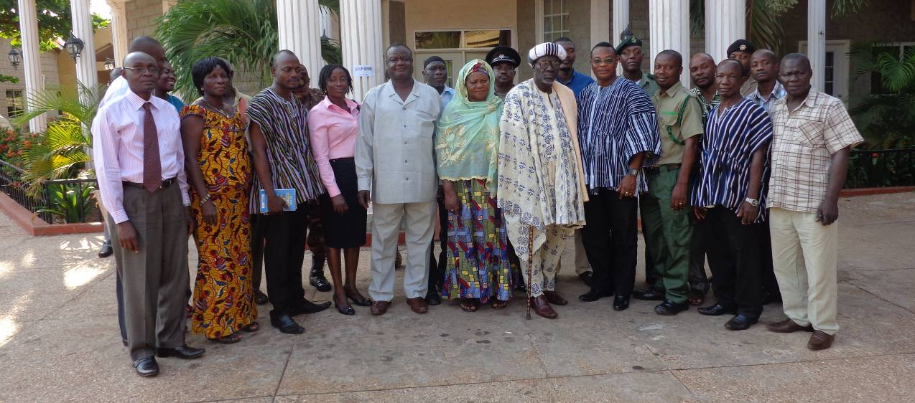
Figure 9: Tamale Participants

Welcome Address
The welcome address was delivered by a member of the Council of State and Chairman of the Regional Platform for Disasters, Vo-Naa Bawah.

CREW Project Overview, Baseline Data, and Workshop Objectives
Dr. Kingsford Asamoah, the CREW project manager presented an overview of the CREW project, the objectives of the regional consultative workshop as well as baseline data on disasters in the country that was culled from the Daily Graphic for the period spanning 1987 to present.

Questions and Comments

- Since the CREW Project is focusing on floods and droughts, what about human conflicts and bush fires?
Response: I understand the scope of the CREW project is in droughts and floods but there could be cross cutting issues e.g. the WEBEOC.

- Since NADMO as the Implementing Partner already has financial problems how would the project fare with regard to finances?
Response: The Norwegian government is providing funding for the CREW project with support from the UNDP.

- Can we know which district has been selected for the Northern Region?
Response: This workshop is partly to enable stakeholders contribute to the site selection.

Session 1: Envisioning an Effective Regional Early Warning System
The first session of the workshop focused on two group activities. The first activity was a word game that focused on stimulating creative and “out-of-the-box” thinking in envisioning an effective early warning system. Participants were split into groups and asked to come out with synonyms to words such as community, disaster, resilience and early warning and to ultimately provide their own understanding and definition of what CREW stands for. Table 18 presents the collated outputs from the various groups from this exercise. The second activity of session 1 was also a group exercise on designing a flood/drought resilient community and the presentation of the corresponding output by group leaders in the plenary session.

Table 18: Synonyms of key words given by participants in Tamale
Community | Village, Town, Hamlet, Suburb, Locality, Neighbourhood
Disaster | Danger, Havoc, Trouble, Mishap, Destruction, Inferno, Calamity
Resilience | Bridges, Embankment, Tree Planting, Desilting, Reconstruction, Withstand, Resistance, Robust, Endurance
Early Warning | Awareness, Education, Sensitization, Signals Prior Information, Town Crier, Drumming, Alarm, Proactiveness.

Session 2: Recent Efforts Related to Early Warning System in Ghana and the Region
The second session of the workshops comprised two presentations that dwelt on recent efforts related to flood and drought risk mapping through AAP and indigenous knowledge on flood and drought early warning respectively. Mr. Philip Mantey, the CREW Technical Advisor delivered a presentation on the flood and drought risk mapping assignment undertaken in 5 pilot districts under the African Adaptation Project. The beneficiary districts were Aowin Suaman in the Western Region, Fanteakwa in the Eastern Region, Keta in the Volta Region, West Mamprusi in the Northern Region and Sissala East in the Upper West Region.The presentation focused on a GIS based approach to modelling flood and drought risk in the pilot districts using meteorological and topographical data in a multicriteria framework. The output maps were symbolised using a traffic light code of red-yellow-green denoting high risk-medium risk-low risk areas to drought or flood. The presentation showed the importance of knowing the spatial risk levels for different areas within the districts to enable the proper citing of safe havens and evacuation routes in case of flood disasters in particular.

The second presentation focused on indigenous knowledge on flood and drought early warning was presented by Dr. Kingsford Asamoah, the CREW Project Manager. This focused on district specific indigenous early warning knowledge on droughts and floods also from the five AAP pilot districts already mention. The indigenous knowledge on flood and drought early warning are based on the observation of natural occurrences such as the movement of animals, weather signs that have over time been associated with the flood and drought events as experienced by the indigenous populations in these districts.

Session 3: Pilot Sites Selection
The pilot site selection exercise by participants was based on a scoring matrix developed by the CREW Research Technical Working Group (See Annex III). The five top districts for flood and drought disasters in the region as selected by participants are presented in Table 19.

Table 19: Top 5 Flood and Drought Prone Districts in the Northern Region
Flood | Drought
Savelugu Nanton | North Gonja
Saboba | Bunprugu Yunyoo
West Mamprusi | Manprugo Maoduri
North Gonja | Tamale
Karaga | Bole

Upper East Regional Consultative Workshop Report

Workshop Opening
The Upper East Regional consultative workshop was held on the 4th December 2013 in Bolgatanga at the Blue Sky Hotel. The workshop was opened with a prayer by a participant. This was followed by the introduction of participants (Fig 10). The list of the participants of the Upper East Regional Consultative Workshop is provided in Annex V.

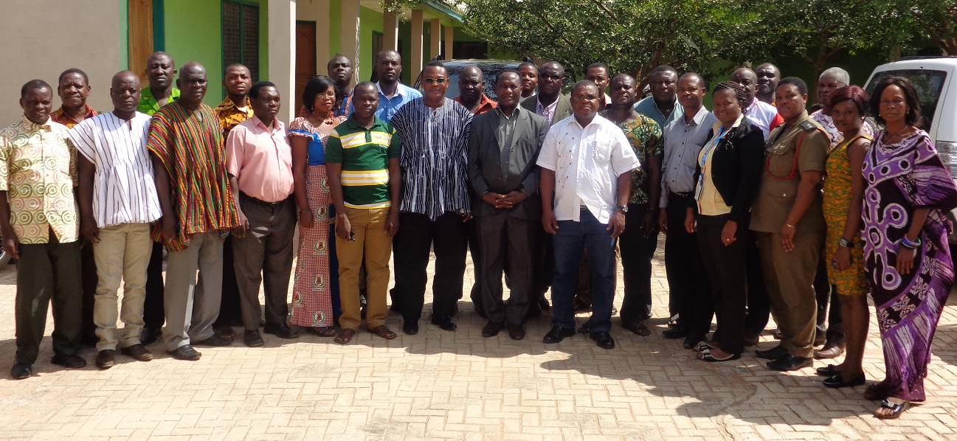
Figure 10: Bolgatanga Participants

Welcome Address

CREW Project Overview, Baseline Data, and Workshop Objectives
Dr. Kingsford Asamoah, the CREW project manager presented an overview of the CREW project, the objectives of the regional consultative workshop as well as baseline data on disasters in the country that was culled from the Daily Graphic for the period spanning 1987 to present.

Session 1: Envisioning an Effective Regional Early Warning System
The first session of the workshop focused on two group activities. The first activity was a word game that focused on stimulating creative and “out-of-the-box” thinking in envisioning an effective early warning system. Participants were split into groups and asked to come out with synonyms to words such as community, disaster, resilience and early warning and to ultimately provide their own understanding and definition of what CREW stands for. Table 20 presents the collated outputs from the various groups from this exercise. The second activity of session 1 was also a group exercise on designing a flood/drought resilient community and the presentation of the corresponding output by group leaders in the plenary session.

Table 20: Synonyms of key words given by participants in Bolgatanga
Community | Township, Habitat, Neighbourhood, Hamlet, People, Settlement, Dwelling, Habitation, Cottage, Hamlet, Society
Disaster | Destruction, Damage, Hazard, Loss, Havoc, Ruin, Catastrophe, Misfortune, Accident
Resilience | Coping, Adaptation, Remedies, Withstand, Resistance, Strength, Solutions, Endurance, Withstand, Firm, Capability, Management, Strategies
Early Warning | Awareness, Advance Notice, Information, Preparedness, Signals, Sings, Prompting, Pre-emption, Clues.

Session 2: Recent Efforts Related to Early Warning System in Ghana and the Region
The second session of the workshops comprised two presentations that dwelt on recent efforts related to flood and drought risk mapping through AAP and indigenous knowledge on flood and drought early warning respectively. Mr. Philip Mantey, the CREW Technical Advisor delivered a presentation on the flood and drought risk mapping assignment undertaken in 5 pilot districts under the African Adaptation Project. The beneficiary districts were Aowin Suaman in the Western Region, Fanteakwa in the Eastern Region, Keta in the Volta Region, West Mamprusi in the Northern Region and Sissala East in the Upper West Region.The presentation focused on a GIS based approach to modelling flood and drought risk in the pilot districts using meteorological and topographical data in a multicriteria framework. The output maps were symbolised using a traffic light code of red-yellow-green denoting high risk-medium risk-low risk areas to drought or flood. The presentation showed the importance of knowing the spatial risk levels for different areas within the districts to enable the proper citing of safe havens and evacuation routes in case of flood disasters in particular.

The second presentation focused on indigenous knowledge on flood and drought early warning was presented by Dr. Kingsford Asamoah, the CREW Project Manager. This focused on district specific indigenous early warning knowledge on droughts and floods also from the five AAP pilot districts already mention. The indigenous knowledge on flood and drought early warning are based on the observation of natural occurrences such as the movement of animals, weather signs that have over time been associated with the flood and drought events as experienced by the indigenous populations in these districts.

Session 3: Pilot Sites Selection
The pilot site selection exercise by participants was based on a scoring matrix developed by the CREW Research Technical Working Group (See Annex III). The five top districts for flood and drought disasters in the region as selected by participants are presented in Table 21.

Table 21: Top 5 Flood and Drought Prone Districts in the Upper East Region
Flood | Drought
Bolgatanga | Kasena Nankana East
Kasena Nankana East | Kasena Nankana West
Bawku West | Bawku
Pusiga | Bawku West
Garu Tempane | Builsa South

Appendix I: CREW Inception Workshop Programme

Inception Work Shop | Weekdays in Nov/Dec 2013

9.00 am Workshop Opening:
9:15 Introduction of Participants: Self Introduction
9:30 Welcome Address: – Mr Kofi Portuphy (NADMO-National Coordinator)
9:40 CREW Project Overview, Baseline Data, and Workshop Objectives: – CREW Project Manager

10.00 am Session 1: Envisioning an Effective Regional Early Warning System: - Dr. Asamoah (CREW/PMU-PM)
Visioning Group Work: (Detailed Group Work exercise on designing a flood resilient community)
Presentation of Group Work: Group Leaders

11:15 Short Break

11.30 am Session 2: Recent Efforts Related to Early Warning System in Ghana and the Region Flood and Drought Hazard Mapping through AAP – Phil Mantey (CREW/PMU-TA)
Flood Mapping along the White Volta – Dr. Asamoah (CREW/PMU-PM)
Efforts to Transition from Manual to Automated Weather Information Gathering, Forecasting and Archiving – Dr. Asamoah (CREW/PMU-PM)
Indigenous Knowledge on flood and drought Early Warning - Dr. Asamoah (CREW/PMU-PM)

12.30 pm Lunch

1.30 pm Session 3: Contextualizing the CREW Project to the Regional Level
Group Work or Survey by Themes:
Partnership, Communication and Coordination – How can regional stakeholders effectively work with national and district stakeholders for effective EW information communication?
Baseline Data Validation – Participants to share and examine existing baseline info on disasters, identify gaps and provide supplementary information and sources if any.
Pilot Sites Selection based on developed criteria - select pilot sites using scoring matrix
Group Presentations

4.00 pm Session 5: Reflection and Way Forward (Moderator)

Post workshop survey

Appendix II: Word Game

Play Word Game (Synonyms)
Key Words to be Explored (20 minutes)
GROUP #/
MEMBERS
Community
Disaster
Resilience
Early Warning

Appendix III: Site Selection Matrix
APPENDIX IV: POST WORKSHOP PARTICIPANT SURVEY

2013 | CREW REGIONAL STAKEHOLDERS WORKSHOP
Background Information
Name (optional): _______________________________________________________________
Gender: Male Female
Age Group: Below 19 20 – 29 30 – 39 40 – 49
50 – 59 60 – 69 70 and above
Organization Name: _______________________________________________________
Sector: National Government Local Government Academic
Private Sector (which sector?) Civil Society Organization
Bilateral Aid Agency International Development Agency
Banks Other (please elaborate: ____)

Q1. What key knowledge/information have you gathered throughout the workshop?
Level of Understanding
High Med Low None
Existing and future work on disaster risk reduction (DRR) in Ghana
Existing and future work on early warning (EW) in Ghana
Objectives, activities, and plans of Crew Project
Effective communication methods related to DRR and EW
I was able to share my ideas in regard to Crew Project Site Selection
Other: please write below

Q2. Are you interested in participating in future CREW project activities? If so, how?
Are you interested in participating in future CREW project activities? | Yes No
If Yes, in what way are you interested in participating?  Be part of the Regional Disaster Management Committee  Participate in future information sharing sessions  Other: please elaborate below | Please indicate your preferred contact details.  Email: ______________  Phone: ______________
If No, is there a particular reason? Please elaborate below

Appendix V: TERMS OF REFERENCE

Community Resilience through Early Warning (CREW) Project
Regional Inception Workshops
Tuesday 12th November - Friday 7th December, 2013

1. Background

Disaster Risk Reduction (DRR) is an urgent and significant development issue in Ghana. Recognizing the importance of strengthening DRR capacities in achieving sustainable development and poverty reduction in Ghana, the National Disaster Management Organization (NADMO) with funding from the Government of Norway, and in partnership with the United Nations Development Programme (UNDP), has initiated the “Community Resilience through Early Warning (CREW) Project.” Over the three-year (2013 to 2015) implementation period, the CREW Project aims to build capacities within the country to reduce disaster risk by putting in place an integrated early warning system that is both scientific and people-centred.

The project is designed in a way that aligns it with the Hyogo Framework of Action and the Ghana Plan of Action for DRR and CCA, and leads to tangible results at both national and community levels. Through the implementation of hazard mapping, early warning, and vulnerability assessment and reduction, the CREW Project aims to achieve 1) reduction of economic and human losses and damages from priority disasters, and 2) establishment of effective early warning and communication for priority hazards to reduce disaster risks in 10 pilot sites by 2015.

Following the official launch of the CREW project at the national level in Accra, there is the need to hold Regional workshops to formally inform and launch the Project for key stakeholders in the ten (10) beneficiary Regions of the country and also gather preliminary baseline information as part of the activities towards the successful implementation of the project. The one-day technical workshop would involve key regional actors related to the management of climate induced disasters as well as those germane to the establishment of Early Warning System (EWS) in the 10 regions of Ghana.

2. Objectives

The objectives of the Technical Workshop are to:
- Formally introduce and inform regional stakeholders regarding the CREW Project
- Build partnership amongst key regional stakeholders to enhance the implementation of the CREW Project
- Validate baseline data on disasters in the region for M&E purposes
- Choose tentative pilot sites for DRR and EWS activities using scoring matrix

3. Proposed Programme & Participants
Please see Annex 1 and 2.

4. Estimated Budget Summary

Item description | Qty | Unit Cost GH¢ | Frequency | Total cost GH¢
DSA
88% PMU (Coordinator+PM+TA) | 3 | 233.2 | 4 | 2,798
100% PMU (Coordinator+PM+TA) | 3 | 265 | 5 | 3,975
100% PMU (Driver) | 1 | 132 | 9 | 1,188
88% UNDP Staff (NTS) | 1 | 233.2 | 4 | 933
100% UNDP Staff (NTS) | 1 | 265 | 5 | 1,325
88% UNDP Staff (PO) | 1 | 233.2 | 2 | 466
100% UNDP Staff (PO) | 1 | 265 | 2 | 530
100% UNDP Staff (Driver) | 1 | 265 | 4 | 1,060
Sub Total |  |  |  | 12,276
T & T For Participants
Takoradi & Accra | 31 | 25 | 2 | 1,550
Ho and Koforidua | 31 | 20 | 2 | 1,240
Sub-Total |  |  |  | 2,790
Conference Cost
Cost of conference package for 35 Persons | 35 | 80 | 4 | 11,200
Sub-Total |  |  |  | 11,200
Total Budget |  |  |  | 26,266

5. Expected Outputs and Deliverables

The CREW regional Inception Workshops will result in the following outputs and deliverables:
- Regional Inception Workshop Report – that includes information and discussion related to the validation of available data and their sources (i.e. reports, study) (By 31 Dec, 2013)
- Pilot Site Selection Report - Using site selection scoring Matrix from RTWG workshop (By 31 Dec, 2013)

6. M&E Plan
A survey instrument will be developed and filled by participants exploring the effectiveness of the workshop achieving the intended outcome. Gender and age disaggregated data will be collected and analysed.

Furthermore, as indicated in the above section, pre-workshop and post workshop surveys and/or information gathering will be conducted in order to verify and update M&E Framework as well as gather appropriate baseline information.

7. Communication Plan
CREW Team to ensure that the CREW Project is effectively communicated to key stakeholders to foster interest and support to the project, as well as raise general awareness regarding the importance of making communities in the region more resilient to disasters through the establishment of an effective EWS.

Pre-Event
CREW Team will print programmes for the workshops.
CREW Team will identify information gaps which we need to request the specific regional stakeholders to provide/share at the workshop

During the Event
CREW Team will gather participants’ perceptions on how to make communities in Ghana disaster resilient through enhancing their access to information.

Post-Event

CREW Team will upload communication materials on CREW Project website.

8.0 Travel and Workshop Itinerary

Day | Date | Task
Wed | 13-11-13 | Volta Region Workshop
Fri | 15-11-13 | Western Region Workshop
Mon | 18-11-13 | Central Region Workshop
Wed | 20-11-13 | Eastern Region Workshop
Fri | 22-11-13 | Greater Accra Workshop
Mon | 25-11-13 | Ashanti Regional Workshop
Wed | 27-11-13 | Brong Ahafo Regional Workshop
Fri | 29-11-13 | Upper West Regional Workshop
Mon | 02-12-13 | Northern Regional Workshop
Wed | 04-12-13 | Upper East Regional Workshop

Appendix VI: Participant Lists for CREW Regional Consultative Workshops

THE COMMUNITY RESILIENCE THROUGH EARLY WARNING PROJECT REGIONAL CONSULTATIVE WORKSHOP - VOLTA REGION, HO ATTENDANCE LIST
NO | NAMES | ORGANISATION | CONTACT
 | AMENYO JACOB | PHYSICAL PLANNING | 0244211866
 | GEORGE ETORNAM A. | REG. HYDROLOGICAL DEPT. | 0244821743
 | SUMAILA OSUMANU | TCPD | 0244025454
 | ALFA ANAS HAMIDU | MUSLIM COMMUNITY | 0268167339
 | LT. COL. GYESEN NYANKEH | MILITARY | 0508131622
 | KWASI ATTOR | NADMO MUNICPAL CO. | 0208331196
 | STEPHEN DUSSEY | METEO. AGENCY | 0246621762
 | PHILIP MANTEY | CREW | 0261563166
 | STEPHEN KANSUK | UNDP | 0204751972
 | SEPENYO DZOKOTO | GNA | 0244856084
 | DR. SIMON SAVOE | EPA | 0246094870
 | K. TACKIE | DSW | 0240603703
 | DSP ANYRATOR CHRISTIAN | PRISON SERVICE | 0242705308
 | ADO1 EMMANUEL BONNEY | FIRE SERVICE | 02433633450
 | KAFUI KLUTSEY | GES | 0243612205
 | HARRY ASIMAH | NCCE | 0243215486
 | AKPLU FOSTER | PWD | 0206559975
 | I C Y APETORGBOR | FORESTRY DEPT | 0244207296
 | FRANK MATTAH | MOFA | 0209185704
 | KWESI MIDAH BENGIN | VRCC | 024237545
 | SUPT. N.O. OFOSUHENE | MUNICIPAL POLICE COMMANDER | 0244821762
 | SYLVESTER EYRAM | CWSA | 0244577613
 | DAVID O. LARTEY | I S D | 0201385200
 | TETTEH ANGELA | NADMO REG. OFFICE | 0201546621
 | CHARLES AMOAH | GIS | 0203527860
 | LARRY YEBOAH | RED CROSS | 0244875229
 | KOBLA ALI KUKUBOR | GBC | 0244077547
 | WINFRED ADZAH | GHS | 0244726236
 | CHARLES AMEVEANKU | VRHC | 0243332722
 | SIMON MILES BAKAH | NADMO REG. OFFICE | 0244968718
 | PASCHAL AGBAGBA | NADMO REG. OFFICE | 0543524606
 | RAPHAEL ASULIWONNU | UNPD | 05489929412
 | DR. KINGSFORD ASAMOAH | CREW NADMO | 0547776056
THE COMMUNITY RESILIENCE THROUGH EARLY WARNING PROJECT REGIONAL CONSULTATIVE WORKSHOP - WESTERN REGION, TAKORADI ATTENDANCE LIST

NO. | NAME | ORGANISATION | EMAIL | PHONE
 | DR. KINGSFORD ASAMOAH | CREW NADMO | kingasam@gmail.com | 0547776056
 | PHILIP MANTEY | CREW NADMO | philmantey@gmail.com | 0261573166
 | EBENEZER SAM | G.N.F.S | ndeboasam@yahoo.com | 0206619365
 | GOODWILL ARTHUR-MENSAH | G.N.A | mensahgoodwill@gmail.com | 0245539984
 | DAVID PERRY OSIKA | METEO | dposika@yahoo.com | 0243102899
 | ANASTES B. CUDJOE | METEO | anastesbcudjoe@yahoo.com | 0208089778
 | AMA A. KYERE Q. | T.C.P.D | nanaamakyere@yahoo.com | 0201966172
 | AAUAGUSTUS J. LAMPTEY | GHANA NAVY | augjoelamp@yahoo.com | 0269314901
 | RAPHAEL ASULIWONNU | UNDP | r.assuliwonnu@yahoo.com | 0548992942
 | STEPHEN KANSUK | UNDP |  | 0204752922
 | KWEKU AGYEMANG DUAH | D.S.W | agyemangkweku@yahoo.com | 0246294217
 | FRANCIS Y. TACHIE | G.I.S | tyf1001@yahoo.com | 0244610022
 | KUUPUOLO GAETEN TIM | C.W.S.A | gkuupoulo@yahoo.com | 0244978982
 | KWABENA ADU -BONNAH | FORESTRY COMM | adubonnahk@ymail.com | 0244761887
 | BAIDOO JAPHET | NADMO | japhetbaidoo@yahoo.com | 0249735323
 | J.P ATTA | D.P.D/R.C.C | johnatta98@yahoo.com | 0208222466
 | MATTEW BOATENG | GHANA RED CROSS | vimdakia@yahoo.com | 0203915085
 | ALPHONSUS ARTHUR | N.C.C.E | alphonsusarthur@yahoo.com | 0202088037
 | REV. JOHN E. KWOFIE | CHRISTIAN COUNCIL | morde2004@yahoo.co.uk | 0202577778
 | MAC ZORMELO | MOFA-PPRD | maczormelo@yahoo.com | 0246035566
 | F.ADU-GYAMFI | PUBLIC WKS DEPT. | f.adugee@yahoo.co.uk | 0200510714
 | HAMBAL ADAM | E.P.A | suhiyini76@yahoo.com | 0244098145
 | NANA BILSON | NADMO | nana_bilson@yahoo.com | 0246788100
 | THERESA M. MENSAH | NADMO | theresa.mensa81@yahoo.com
 | NORA IMBEAH | G.E.S | nora.imbeah@gmail.com | 0243722332
 | REV.G.W. DEDJOE- DZOKOTO | HYDRO SERV. DEPT |  | 0208164178
 | ALAHAJI NASSER ALI | MOSLEM COUNCIL |  | 0204111000
 | MICHAEL OCLOO | INFOR. SERV. DEPT | michaelocloo@yahoo.com | 0208188207
 | CATHERINE ENNINFUL | NADMO |  | 0243247944
 | LILY AANYIMIA A. | PLATFARM | amosah@yahoo.com | 0242933901
 | FATI AZIZ | NADMO | ifatiaziz@gmail.com | 0244873780
 | BABARA A. YANKEY | G.H.S | babieyanks@yahoo.com | 0207888986
 | JAMES NUVI | NADMO |  | 0242713161
 | KOBINAH ACQUAH | DAILY DEMOCRAT |  | 0275952785
 | YAABA Y. | NEW STATESMAN | yaaba2005@yahoo.com | 0242236401

THE COMMUNITY RESILIENCE THROUGH EARLY WARNING PROJECT REGIONAL CONSULTATIVE WORKSHOP – CENTRAL REGION, CAPE COAST ATTENDANCE LIST

NO. | NAME | ORGANISATION | EMAIL | PHONE
 | EDWARD HENRY THOMPSON | NADMO | eddytom65@yahoo.com | 0244708972
 | E. SANDY ARYEETEY | NADMO |  | 0299310299
 | MAXWELL APEAKORANG | I.S.D |  | 0287255502
 | ADP S.C. OTABIL | GH. PRISONS | ota302@yahoo.com | 0277407628
 | ASIAMAH BREMPONG | P.W.D | asiamahbrempong@yahoo.com | 0208184147
 | MUSTAPHA GARIBA | MUSLIM COUNCIL |  | 0244721594
 | JOHN E. ADDO | GH. RED CROSS |  | 0244835662
 | JUSTINA PAAGA | G.N.A | justie2008@yahoo.com | 0244715112
 | YUSIF F. ADAMU | NADMO | yufadam@yahoo.com | 0244839738
 | PHILIP ARTHUR | G.I.S | arthurphilip64@yahoo.com | 0242305626
 | FREDERICK NYAME | PLANNING, RCC |  | 0240466820
 | K. OWUSU SEKYERE | E.P.A |  | 0244583882
 | KWAMENA DADZIE DENIS | DEPT. OF SOCIAL WELFARE |  | 0244211191
 | EBENEZER OKINE | HYDRO SERVICES | okayibontey@yahoo.com | 0276031843
 | D.K.M STEPHENS | GH. EDUCATION SERVICE | dkmstephensus@yahoo.com | 0246220036
 | AUGUSTINE MENSAH | MOFA |  | 0205885828
 | RICHARD BAFFOE ASARE | NADMO | richardbaffoeasare@yahoo.com | 0244828128
 | ALHAJI OSMAN FUKUYAMA | NADMO | wayoda@yahoo.com | 0244824115
 | RAPHAEL ASULIWONNU | UNDP |  | 0548992942
 | CHARLOTTE NORMAN | NADMO | charlottenorman72@yahoo.com | 0209875188
 | ASP CEPHAS EDZEANI | GH. POLICE SERVICE | cephasedzeani@yahoo.com | 0208779861
 | PHILIP MANTEY | CREW-NADMO | philmantey@gmail.com | 0261563166
 | DR. KINGSFORD ASAMOAH | CREW-NADMO | kingasam@gmail.com | 0547776056

THE COMMUNITY RESILIENCE THROUGH EARLY WARNING PROJECT REGIONAL CONSULTATIVE WORKSHOP – EASTERN REGION, KOFORIDUA ATTENDANCE LIST

NO. | NAME | ORGANISATION | EMAIL | PHONE
 | DR. KINGSFORD ASAMOAH | CREW NADMO | kingasam@gmail.com | 0547776056
 | PHILIP MANTEY | CREW NADMO | philmantey@gmail.com | 0261573166
 | ATUAHENE AGYEMANG | G.H.S | atuaheneghsk@yahoo.com | 0540577259
 | LYDIA ASANTE | NADMO | yaakyerewa@yahoo.com | 0541403219
 | EMMANUEL TAKYI | T.C.P.D | sweettakyie@yahoo.com | 0244431216
 | FREDERICK GYEBI T. | MOFA |  | 0244775031
 | NANA KWAKU | DAILY GRAPHIC |  | 0242604092
 | D.M KORSAH | G.N.F.S |  | 0203779056
 | SARAH KWAO | SOCIAL WELFARE |  | 0244069617
 | AMA TAKYIWAA A.NYARKO | GHANAIAN TIMES |  | 0245148210
 | YVONNE NEEQUAYE | TV3 | y.neequaye@yahoo.com | 0242320402
 | RAPHAEL ASILIWONNU | UNDP
 | OPPONG BISMARK | EASTERN FM |  | 0249525583
 | REXFORD.K. AGYARKO | G.E.S |  | ‘0208301126
 | VICTOR GRANKSON | P.W.D |  | 0243215878
 | HORATIOUS KOFI ASANO | F.S.D |  | 0241423950
 | BENNET DZOGBELU | I.S.D |  | 0243215878
 | K. ANOKYE AIDER | METEO |  | 0201981097
 | GODWIN Y. ANKU | G.H.A |  | 0246313645
 | ALFRED AGYEMANG | NADMO |  | 0243127390
 | S.A. VONDEE | CHRISTIAN FEDERATION |  | 0244018071
 | THEOPHILUS TACKIE | GH.RED CROSS |  | 0208208463
 | GOERGE P. AGYEMANG | C.W.S.A |  | 0236833397
 | BAFFOUR NYANTAKYI T.B | REP. FOR DAASEBRE |  | 0241937034
 | MACANTHONY D. | G.N.A | mctonnydag@gmail.com
 | CHRIS QUARCOE | GH. POLICE
 | AGBESI E. SERLOM | NADMO | agbe.serlom@yahoo.com
 | GEORGE B. KONLAN | N.C.C.E | gkonlab@yahoo.com
 | PHILIP NARTEY | PLAN GHANA | phillnartey@yahoo.com
 | JOHN B TORTO | NAT. SECURITY
 | SGT. OWUSU ANSAH | IBN of INF |  | 0244612643
 | F. ADDAI | E.P.A |  | 054301748
 | ABASS FUSEINI | E.P.A |  | 0243110178
 | FRANK N. AGRREY | NADMO |  | 0244572775
 | EBENEZER ADOMAKO MENSAH | REG. ECON. PLG. ERCC |  | 0243605351
 | NUTEFE MARTIN | NADMO |  | 0267010585
 | IBRAHIM ISSAKA | KASPD |  | 0248659273
 | KWESI OPARE | NADMO |  | 0247644606
 | RANSFORD O. BOAKYE | NADMO |  | 02448856255

THE COMMUNITY RESILIENCE THROUGH EARLY WARNING PROJECT REGIONAL CONSULTATIVE WORKSHOP – GREATER ACCRA REGION, ACCRA ATTENDANCE LIST

NO. | NAME | ORGANISATION | EMAIL | PHONE
 | SPENDILOVE FRIMPONG | REGIONAL AGRIC | roomfel@yahoo.com | 0248620962
 | GEORGE MENSAH | REG. PLATFORM | paageorge5@gmail.com
 | NENE ABRAM AKUAKU II | PARAMOUNT CHIEF |  | 0249136306
 | HAJJ ABDALLAH TETTEH | GH. MUSLIM MISSION | ghmussmission@yahoo.com | 0244486029
 | CAPT. ATSU AGBENYEGAH | 48 ENGINEERS REGIMENT | atsu2u@yahoo.com | 0244203333
 | MAJOR S.S. LOKPA | 5th INFANTRY BATALION | senascare@gmail.com | 0244730920
 | ASP JOSEPH KAGUAH | GH. PRISONS | joekagua@gmail.com | 0244167078
 | BENJAMIN A. OTOO | SOCIAL WELFARE DEPT. | benjina4us@yahoo.com | 0244521115
 | CECELIA ACHEAMPONG | TOWN & COUNTRY PLAN. | joycecelia40@yahoo.com | 0246629350
 | JOSEPH OTOO | NADMO |  | 0244648175
 | EVANS ANAKWAH | NADMO |  | 0244778034
 | FELIX DONKOR BADU | C.W.S.A | fingaro2000@yahoo.com | 0244682800
 | OSMAN ARYEETEY | GH. MUSLIM MISSION | prince2002@yahoo.com | 0244672246
 | LARRY DASMANI | G.N.A | laarygna@gmail.com | 0203818744
 | ERIC ASAMOAH DARKO | GHANA RED CROSS |  | 0208132949
 | ANNIE NAA DENSUA COFIE | P.W.D | naadensuaaddy@yahoo.com | 0244738848
 | KODUA EDJEKUMHENE | I.S.D | kedjekumhene@hotmail.com | 0277510476
 | JOSEPH OWUSU AGYEMANG | GH. HEALTH SERVICE | jobella2008@yahoo.com | 0208115578
 | A CFO P.K. DONKOR | G.N.F.S |  | 0244656239
 | MERCY ESSIEN | N.C.C.E | effeba12@yahoo.com | 0244998873
 | DANIEL MENSAH | NADMO |  | 0249288454
 | ABDUL RAZAK QUARSHIE | NADMO |  | 0246728965
 | EBEN A. SADATY | NADMO | ebensadaty@yahoo.com | 0244212351
 | CHARLOTTE NORMAN | NADMO | charlottenorman72@yahoo.com | 0209875188
 | OHENE-KENA FRED | NADMO | nanakena17@yahoo.com | 0244169836
 | EKPE CHARLES | NADMO | n_stonesan@yahoo.com | 0206555814
 | TERRANCE OPPONG | NADMO | terryterrow@yahoo.com | 02426141016
 | RAPHAEL DE-SOUZA | NADMO | radiga@yahoo.com | 0240378216
 | EBEN DOSOO | NADMO | dosooeben@yahoo.com | 0244257408
 | HON. NII DJAMMAH VANDERPUYE | DEP. REG. MINISTER |  | 0243366146
 | NATHANIEL ARYEE | MEDIA | nataryee@yahoo.com
 | DR. KINGSFORD ASAMOAH | CREW NADMO | kingasam@gmail.com | 0547776056
 | PHILIP MANTEY | CREW NADMO | philmantey@gmail.com | 0261573166

THE COMMUNITY RESILIENCE THROUGH EARLY WARNING PROJECT REGIONAL CONSULTATIVE WORKSHOP – ASHANTI REGION, KUMASI ATTENDANCE LIST
NO | NAMES | ORGANISTION | EMAIL | PHONE
 | CAPT. J.K JABARI | MILITARY 4BN | johnkwamejebari@yahoo.com | 0209370615
 | SUPT. N.A ARYEETEY | PRISON SERVICE | niiarmaha@yahoo.com | 0265996898
 | ALHAJI TANKO MOHAMMED | SARKIN ZONGO PALACE |  | 0208235678
 | RAPHAEL ASULIWONNU | UNDP
 | ASOBAYIRE BENEDICT | NADMO REG. OFFICE |  | 0204600014
 | KWAME ASARE | RED CROSS | amickyus@yahoo.com | 0245744127
 | REV. FR. PATRICK OSEI-POKU | CATH. SECRETARIAT | patop@live.com | 02030120322
 | BRIGHT ANITEGE | H S D | Abanitiye@yahoo.com | 0208165751
 | ALHASSAN YAKUBU | NCCE | Ayakuba2009@yahoo.com | 0244764155
 | JACOB ACHULO | SOCIAL WELFARE | jacobachulo@yahoo.com | 0208546309
 | ISSAC K. AMOH | INFORMATION SERV. | amohissack@gmail.com | 0506926715
 | NANA KOTOKO AMEYAW | PLATFORM CHAIRMAN |  | 0204295416
 | ASANTE ASUBONTENG | GMET |  | 0202018768
 | FRANK EBO YARIEL | TOWN AND COUTRY PLANNING | yarielfrank@yahoo.com | 0208425828
 | ACKAH DESMOND ESSOM | GHANA FIRE SERVICE | Desmondodesuame22@yahoo.com | 0242319653
 | KOJO DARKO-ASANTE | PWD | iceghplus@gmail.com | 0244721698
 | ADARKUA YADUM | EPA | yiaprem@yahoo.com | 0547977555
 | THOMAS KWAME ADJEI | IMMIGRATION SERVICE | tomdjei@yahoo.com | 0244773116
 | GEORGINA PORTIA ANSAH | G E S | georginaportia@gmail.com | 0244385967
 | JOSEPH DONKOR | RCC | joedonkor06@yahoo.com | 0244844570
 | ISSAC K. AMOH | FOREST SERVICE DIVISION | nabeshun@hotmail.com | 0243556188
 | TANKO HUSEINI | ZONGO YOUTH | fuseinitanko@yahoo.com | 00242288239
 | NANA BOAMA KWABI | BEPOSO TRADITIONAL COUNCIL |  | 0243648150
 | VIVIEN AKUMA | NADMO REG. OFFICE | vivienakuma@yahoo.com | 0244666456
 | ANINKORA SIE K. | NADMO REG. OFFICE | aninkosie@yahoo.com | 0242640296
 | PHILIP MANTEY | CREW | philmantey@gmail.com | 02261563166
 | DR. KINGSFORD ASAMOAH | CREW NADMO | kingasam@gmail.com | 0547776056
 | GIFTY H. KORSAH | NADMO REG. OFFICE | nanaawoa322@gmail.com | 0541717802
 | SAMUEL BOATENG | NADMO REG. OFFICE |  | 0299350377
THE COMMUNITY RESILIENCE THROUGH EARLY WARNING PROJECT REGIONAL CONSULTATIVE WORKSHOP – BRONG AHAFO REGION, SUNYANI ATTENDANCE LIST

NO. | NAME | ORGANISATION | EMAIL | PHONE
 | AMPONSAH BOATENG | GH. HEALTH SERVICE | amponsteve@yahoo.com | 0204060727
 | RAPHAEL ASULIWONN | UNDP
 | LT. GEN APEAGYEI | MILITARY |  | 0266011443
 | JOANA MENSAH | NADMO | akosuaakos@yahoo.com | 0244587924
 | PAUL AYERIKOLO | MOFA | paulayerikolo@yahoo.com | 0208543617
 | ATTA YEBOAH | NADMO | attayeboah2@yahoo.com | 0244637347
 | BERNICE FRIMPONG | NADMO | bernicefrimpong@yahoo.com | 0244183480
 | APPIAH KUBI AMOS | NADMO | amosappiahkubi@gmail.com | 0208826497
 | KOMLADZEI E. DIVINE | CSWA-BAR | ethelbertk@yahoo.com | 0540995222
 | KYEI BAFFOUR ERIC | NADMO | Erick.@yahoo.com | 0246236753
 | SYLVERSTER AWOZUM | E.P.A | sawozum@yahoo.com | 0242363044
 | KOFI OWUSU ANI | TCPD | kofiowuwani@yahoo.com | 0242815401
 | AKWESI AMANKWA | I.S.D |  | 0208228022
 | OPOKU ANTOINETTE | RCC | nanaesiopoku@yahoo.com | 0209359499
 | ERIC J. ADJEI | RCC | ericjones@yahoo.com | 0204242429
 | J.B. NYAKO | NADMO | jbnyako@yahoo.com | 0208409505
 | DANIEL SIAW | UENR | dekasiaw2007@yahoo.com | 0208154871
 | KPAJAL DANIEL | G.N.F.S |  | 024682239
 | MERCY KETTENI | NADMO | kettenim@htmail.com | 0208217522
 | AMPONSAH VIDA | NADMO | nanakwa2011@hotmail.com | 0208064780
 | ZINAT ADAM | NADMO | zinatadam2012@yahoo.com | 0263223120
 | AKORSAH ELLEN | NADMO | ellenakorsah@gmail.com | 0246915344
 | PATRICK ACHEAMPONG | DEPT.OF SOCIAL WELFARE | patrickacheampong74@yahoo.com
 | CHARLES DIAWOH | NADMO |  | 0243422830
 | PATRICK FIREMPONG | GNA | piesie1954@yahoo.com | 0244299344
 | AMPABENG KYEREMAH | METEO |  | 0243851091
 | REJOICE BANIBENSU | METEO |  | 0242151075
 | REV. T. KANKAM-DWUNFOUR | ANGLICAN CHURCH | dtimkan@yahoo.com | 0242248188
 | ASP. ISAAC APENTENG | REG. POLICE HQR. | mensahapenteng@yahoo.com | 0242661620
 | PETER ADJEI JARPONG | G.I.S | adjeijarpong78@yahoo.com | 0244026926
 | SUALLAH ABDALLAH QUANDAH | MUSLIM COUNCIL | sualquandah@yahoo.com | 0209454230
 | COLLINS MAHAMA | NADMO | mahamacollins62@yahoo.com | 0207191211
 | MUSA NAABONG | THE ENQUIRER | musnaab@yahoo.com | 0271119033
 | DANIEL DONKOR | FORESTRY COMM. | domkordaniel@yahoo.com | 0204800994
 | KWESI LAMPO | NADMO |  | 0209343633
 | ANTHTONY ADDO | NADMO | tony_addo@yahoo.com | 0208117303
 | MARY ALHASSAN | G.R.C.S | maryalhassan47@yahoo.com | 0243930226
 | AHMED IBRAHIM | B.A.H.C | ibrahimain@yahoo.co.uk | 0261614611
 | FREEMAN
 | ANITI JUSTICE | NADMO | anitijh@yahoo.com | 0206464096
 | KINGSLEY DIAWUO | NADMO | amponhkwan@ymail.com | 0244870249
 | ISSAH A. NASAGRI | N.C.C.E | issablai@yahoo.co.uk | 0202088042
 | DR. KINGSFORD ASAMOAH | CREW NADMO | kingasam@gmail.com
 | PHILIP MANTEY | CREW NADMO | philmantey@gmail.com | 0261573166

THE COMMUNITY RESILIENCE THROUGH EARLY WARNING PROJECT REGIONAL CONSULTATIVE WORKSHOP - UPPER WEST REGION, WA ATTENDANCE LIST

NO. | NAME | ORGANISATION | EMAIL | PHONE
 | YAKABU ABINAN | GMET |  | 0209319793
 | ALASIDONOR | NADMO | alasidongor@yahoo.co.uk | 0208388990
 | NAAH JACOB | UWRHC | jacobnaah@gmail.com | 0240160519
 | LATIFA OMAR | JAMIAT ISLAMIYA | P.O.BOX 166 | 0545466700
 | DR. T. DZIVENU | CENTRE FOR DISASTER RESEARCH-USD | tdzivenu@yahoo.com | 0244865637
 | BEINFRED NAAEDER | NADMO | naaeder07@yahoo.com | 0240777192
 | SGT. DARTEY KINGSLEY | MILITARY | kingsleydartey@yahoo.com | 0540291323
 | PHILIP SOWAH | EOCO | adoayi1@yahoo.com | 0208204744
 | BALEGHA MARIAM | GRCS | mariambalegha@yahoo.com | 0245283494
 | YAAGI JOHNBOSCO | NCCE |  | 0208085594
 | BERNARD M. NAAH | GHS | ben_naa@yahoo.com | 0209375282
 | KWEKU M. AFFUL | GNFS | kmafful@gmail.com | 0200885961
 | DSP STEPHEN TETTTEH | GHANA POLICE SERVICE | tettehsab@yahoo.com | 0242587474/0506051061
 | G.S NAAH | DEPT. OF SOCIAL WELFARE |  | 0203548376
 | EMMANUEL LIGNULE | EPA | lignule@yahoo.co.uk | 0501301737
 | RAPHAEL ASULIWONN | UNDP |  | 0208204752
 | ALHASAN BAWAH SEIDU | NADMO |  | 0244710734
 | KPAN JUSTINE | G.E.S | jkpan197@yahoo.com | 02082279760
 | ABDUL RAHMAN L. | RADIO PROGRESS | a.llenst@yahoo.com | 0203472660
 | BANAMWINE MORRIS | GBC | b.mahama@yahoo.com | 0206823133
 | KAMIL BA | THE HERITAGE | baba.kamil@yahoo.co.uk | 0244686494
 | ATO QUANSAH | CWSA | finalato@yahoo.co.uk | 0244989094
 | L.D. WIEDONG | NGO-WA | lwiedongo@yahoo.com | 0208914247
 | THEODORA SEDODE | G.I.S | tsedode@yahoo.com | 0244628944
 | ABOBO ALPHONSE | MOFA-RADIO | aboboa@yahoo.com | 0205573954
 | AFRA CELINE | I.S.D-WA | cafrabena@yahoo.com | 0201000792
 | I.N PUTIAHA | WA MUNIC. ASSEMBLY | issahakunuhuputiaha@yahoo.com | 0208331757
 | ALHASAN SEIDU | NADMO |  | 0206778041
 | PIUS DUMBA | FSD-WA | pius.dumba@yahoo.co.uk | 0208094123
 | ROBERT AWORLUGUTU | PRISONS | aworlugutu@yahoo.com | 0208455796
 | BETRAND ABBEY | RCC | abbey.betrand@yahoo.com | 0209069020
 | DR. AVEA NSOH | RCC-REG. MINISTER | ephraimnsoh@yahoo.com | 0544322356
 | WINSTON C.K. ARTHUR | TCPD-REG DIRECTOR | hillyelt@yahoo.com | 0244572099
 | ABRAHAM DUNAMO | NADMO |  | 0207021541
 | ROBERT LOGGAH | RRP-CHAIRPERSON | babologgah@yahoo.com | 0208072290
 | DR. KINGSFORD ASAMOAH | CREW NADMO | kingasam@gmail.com
 | PHILIP MANTEY | CREW NADMO | philmantey@gmail.com | 0261573166

THE COMMUNITY RESILIENCE THROUGH EARLY WARNING PROJECT REGIONAL CONSULTATIVE WORKSHOP - NORTHERN REGION, TAMALE

ATTENDANCE LIST

NO | NAME | ORGANISATION | EMAIL | PHONE
 | PETER ALHASSAN | HYDRO |  | 02493522761
 | ALHASSAN FATAU | NOR.REG. HSE OF CHIEFS | alhassanfatau@yahoo.com | 0246363866
 | AKPOTOSU-NARTEY CHRISTIAN | PRISON | crantteyahoo.com | 0244796105
 | RAPHAEL ASULIWONNU | UNDP
 | MIJIMAH F. FELICIA | I.S.D |  | 0549626954
 | JACOB LAMBON | METEO | jacobkomong1@yahoo.com | 0246588320
 | ALHAJI M.A. SOLIMBA | NADMO |  | 0548187677
 | DOUGLAS K. KOYIRI | FIRE SERVICE | koyirid@yahoo.com | 0208284332
 | HAJIA ABIBA KASIM | NADMO |  | 0244987897
 | SULLEY ALHASSAN | NADMO |  | 0241257697
 | ABDUL RAHAMANI YUSSIF | GHANA RED CROSS | y.bakkas@yahoo.com | 0206109454
 | VO-NAA M.B BAWAH | PLATFARM |  | 0244764559
 | PAUL KWODE | G.N.A | pkachanga@yahoo.com | 0243453820
 | JULIANA NGMENYAA | DEPT. OF SOC. WELFARE |  | 0244968090
 | ROBERT AGBENYEGAH | P.W.D |  | 02082220051
 | ALHAJI M. BABA | N.C.C.E |  | 0207732674
 | DICKSON ADJEI SAKYI | FORESTRY COMM. | kas200096@gmail.com | 0246235700
 | LAWRENCE AGYEI AGYAPONG | G.I.S | lent1972@yahoo.com | 0244828777
 | IDDRISSU Z. | NADMO |  | 0242566277
 | KUKUA FANCEY | G.B.C |  | 0207555571
 | SYLVESTER Y. GYOGLUU | TOWN & COUNTRY PLAN. | yinubah@yahoo.com | 0277145905
 | DR. JACOB MAHAMA | G.H.S | wundable@gmail.com | 0244027225
 | DR. KINGSFORD ASAMOAH | CREW NADMO | kingasam@gmail.com
 | PHILIP MANTEY | CREW NADMO | philmantey@gmail.com | 0261573166
 | JOSEPH TENABI | C.W.S.A |  | 0246542277
 | ABDALA MOHAMMED | F.S.D |  | 0243519747
 | BABA MOHAMMED | NADMO |  | 020838437
 | ABDUL RAZAK WAHAB | EPA | wahab2@gmail.com | 0207310300
 | ALEXANDER KYEREMEH | G.N.F.S | a.kyeremeh@yahoo.co.uk | 0244012212

THE COMMUNITY RESILIENCE THROUGH EARLY WARNING PROJECT REGIONAL CONSULTATIVE WORKSHOP - UPPER EAST REGION, BOLGATANGA ATTENDANCE LIST

NO. | NAME | ORGANISATION | EMAIL | PHONE
 | GEORGE BABA | NADMO | baagabase@gmail.com | 0207730813
 | ADONDO SUGGEST | G.N.F.S |  | 0208283880
 | ALAAH CHRISTY | NADMO | christianaayaose@yahoo.com | 0208283881
 | SOWAH BERNICE | DEPT. OF COMM. DEV | sowahbernice@yahoo.com | 0261226687
 | MOHAMMED ATILADO | NRSC | mohammedatilado@yahoo.com | 0244501653
 | JACOB AGUMA | NADMO |  | 0240433293
 | KIZITO AKOMINYA | MOFA | kakominya@yahoo.co.uk | 0201898764
 | AYAMMAH SAMUEL | GBC |  | 0509292279
 | BABA AWUNI | GHS | babota1966@gmail.com | 0207239709
 | AMBROSE ASIA | Gmet. AGENCY |  | 0245221464
 | MALIK ABIKO | NADMO |  | 0208256333
 | LARBI GEORGE | FEEDER ROADS |  | 0549685602
 | JAMES AGAMBILA | DEPT.OF SOCIAL WELFARE |  | 0208295399
 | FATIMA ASTANGA | GNA | fastanga@yahoo.com | 0208340208
 | JOE ABARIKE | GH.RED CROSS | abarike2004@yahoo.com
 | MAHAMA KEN KAZAR | NADMO | ken.kazar@yahoo.com | 0245371682
 | AMATA AMOASAH | UN-WFP | amataamoasah@wfp.org | 0544313245
 | VICTOR ATINGA | DEPT. OF RURAL HOUSING |  | 0208040772
 | ASHER NKEGBE | EPA | ashernkegbe@yahoo.com | 0208294658
 | OSMAN MUNTARAKILU | GBC | mkilu69@yahoo.com | 0206664042
 | RAPHAEL ASALIWONN | UNDP
 | ANTHONY A. ANABA | INFO. SERV. DEPT |  | 0206445598
 | SAAWUG ALFRED | NADMO | saawuga@yahoo.com | 0206661117
 | MAURICE ADABINE | NADMO | mauadaabre@yahoo.com | 0209087138
 | DUG-PRYE EUGENE | PRO
 | MUMUNI IBRAHIM |  |  | 024874036
 | SIMON ATANGA | DRIVER |  | 0248969995
 | CLETUS ANAFO | GH. OBSERVER | apangabia@yahoo.co.uk | 0506112909
 | VINCENT AGANDAA | DAILY HERITAGE | vincentagandaa@yahoo.com | 0540208939
 | MARY A. ABANGA | GBC RADIO |  | 0200645412
 | AARON B. ADUNA | WRC | aaronaduna@yahoo.com | 0208234442
 | ERNEST BUGRI | GTV |  | 0202821130
 | DAVID NAAH | GTV |  | 0244948918
 | LAMBERT DAGMAAH | GTV |  | 0267764090
 | P.Y. GLOVER | CWSA | prosper.glover@yahoo.com | 0245406038
 | MUSAH BISMARK | TV3 | bismusah@yahoo.com | 0208914559
 | MOHAMMED AZONG | GNFS | azongm@yahoo.com | 020642823
 | DR. KINGSFORD ASAMOAH | CREW NADMO | kingasam@gmail.com
 | PHILIP MANTEY | CREW NADMO | philmantey@gmail.com | 0261573166

